UNEP-GRID
Performance of Google Earth Engine for tracing mining evolution with/without deforestation and revegetation post-volcanic eruption or glacier retreat
Complementary Certificate in Geomatics
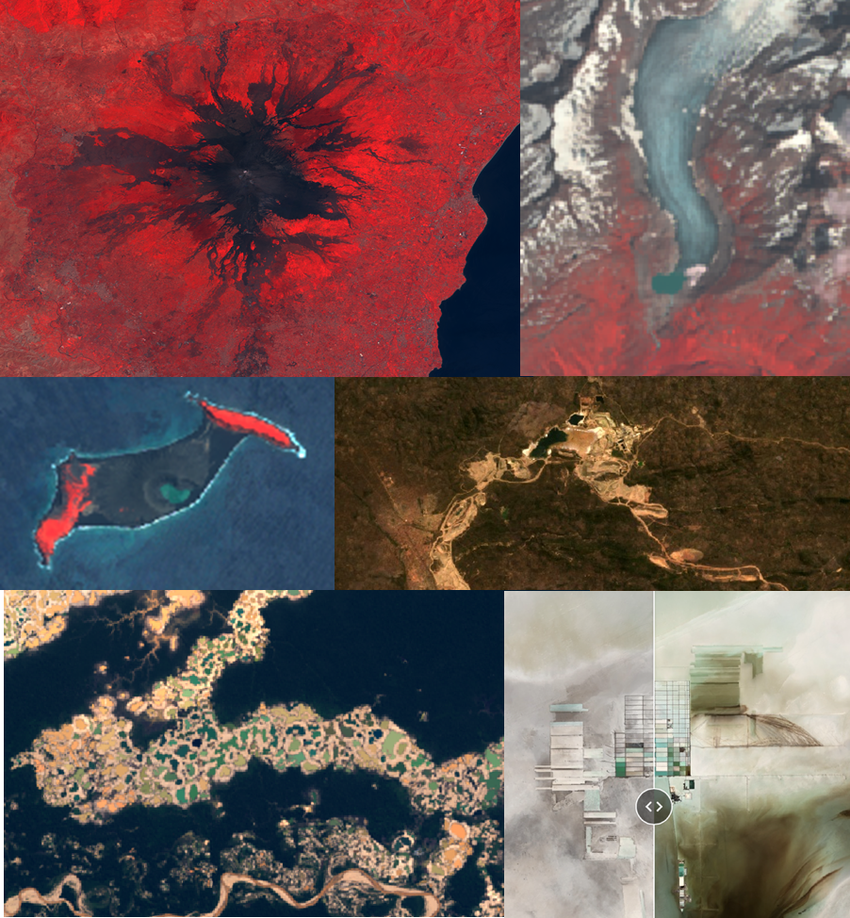
Internship Report
Sara Arcila-Gut

Supervised by : Dr. Gregory Giuliani

September 2019

Abstract
This report resumes the work done during the internship within the GRID-Geneva organization, in the frame of the complementary certificate of geomatics of the University of Geneva. It compiles the results produced during the investigation of six case studies using the “new” cloud-based platform of Google: Google Earth Engine (GEE). These work aimed to test the performance of this platform. During this work, various GEE tools implemented are presented and their performance for remote sensing analyses. How to trace mining expansion through time and quantify their yearly deforestation impact or how to obtain an approximate estimation of the revegetation process after a volcanic explosion or after/during glacier retreat, are some of the processes presented in this work, which can be well and fast performed using GEE.

Résumé
Ce rapport résume le travail effectué pendant le stage au sein de l'organisation GRID-Genève, dans le cadre de l'attestation complémentaire de géomatique de l'Université de Genève. Il compile les résultats obtenus au cours de l'enquête sur six études de cas à l'aide de la « nouvelle » plateforme en nuage de Google : Google Earth Engine (GEE). Ce travail vise à tester les performances de cette plateforme. Au cours de ce rapport, divers outils GEE qui ont été mis en œuvre sont présentés et leurs performances pour des précises analyses de télédétection. Comment retracer l'expansion de l'exploitation minière dans le temps et quantifier leur impact annuel sur la déforestation ou comment obtenir une estimation approximative du processus de revégétalisation après une explosion volcanique ou après/pendant le retrait des glaciers, sont quelques processus présentés dans ce travail, qui ont été bien et rapidement réalisés avec GEE.

Contents
Abstract 2
Résumé 2
1. Introduction 5
1.1. Le GRID – Genève 5
1.2. Google Earth Engine 5
1.3. Objectives of the Internship 6
2. Projects 7
2.1. Tracing Mining Evolution-Growth With or Without Deforestation 7
2.1.1. Uyuni Lithium Extraction (BOL) 7
I. Presentation 7
II. Methods 9
III. Results 11
IV. Discussion 14
2.1.2. Tenke Mine (DRC) 15
I. Presentation 15
II. Methods 16
III. Results 18
IV. Discussion 23
2.1.3. Gold Mining in Madre de Dios (PER) 24
I. Presentation 24
II. Methods 25
III. Results 26
IV. Discussion 28
2.2. Revegetation Post-Volcanic Eruption Or By Glacier Retreat 29
2.2.1. Etna-IT 29
I. Presentation 29
II. Methods 30
III. Results 31
IV. Discussion 34
2.2.2. : Hunga Tonga-Hunga Ha’apai (TGA) 34
I. Presentation 34
II. Methods 35
III. Results 35
IV. Discussion 44
2.2.3. Rhône Glacier (CH) 45
I. Presentation 45
II. Methods 45
III. Results 45
IV. Discussion 48
5. Conclusion 49
6. Perspectives 50
5. Overall Summary of the Internship 50
6. References 51
7. Acknowledgments 53
8. Annexes 53

Introduction
This rapport describes the new-carried mission to investigate the remote sensing performance of the recent cloud-based platform of Google: Google Earth Engine. This task was carried out during a two-month internship from July 22 to September 22, 2019, at GRID (Global Resource Information Database). This internship is part of the complementary certificate in geomatics of the University of Geneva, a training of 30 ECTS which includes 18 ECTS devoted to courses and 12 for which research work or an internship must be carried out.

Le GRID – Genève
The Global Resource Information Database - Geneva (GRID- Geneva) makes part of the Science Division of the UN Environment, inside the Big Data Branch (Figure 1). It is a partnership between the United Nations Environment Program (UNEP), the Swiss Federal Office for the Environment (FOEN) and the University of Geneva (UNIGE). Inside this organization, satellite imagery is processed using remote sensing software, models are created from geospatial data using Geographical Information Systems (GIS) and interactive maps and graphs are generated through their platforms, as MapX. The main topics of interest are Biodiversity, Climate change, Water, Energy, Pollution, Land Cover, Disaster Risk Reduction, Extractives, and Planetary Boundaries. By transforming the data of these topics into valuable and usable information, they support the assessments for sustainable development and the decision making process related to their environmental issues. Parallel to this, this organization designs and maintains data platforms for supporting organizations and they provide conferences and capacity building about Data Science, environmental issues and solutions (source: GRID-Geneva).
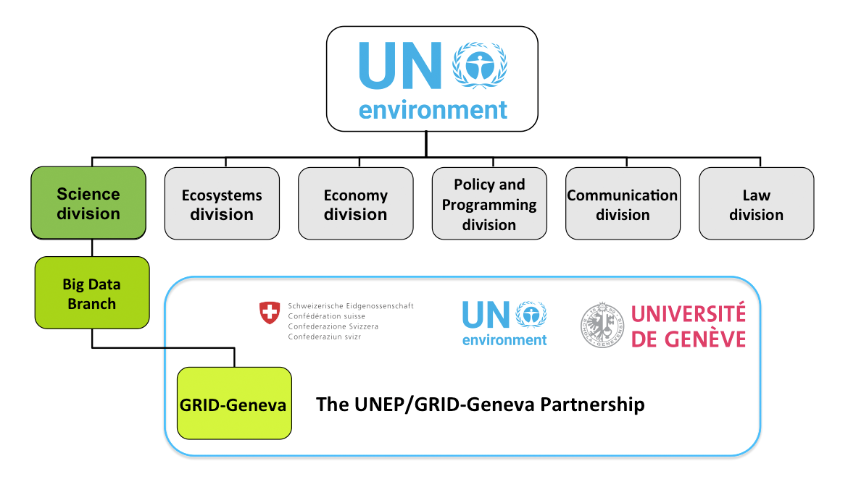
Figure 1. Organigram of the GRID-Geneva.

Google Earth Engine
Google Earth Engine (GEE) is a cloud-based platform containing a multi-petabyte catalog of global satellite imagery and geospatial datasets. This free of charge tool allows the user to create cloud-free, topographically corrected image composites based either on Landsat 5/7/8 (1984-Present, with 30m pixel size resolution) or Sentinel 2 (2015-Present, with 10m/20m pixel size resolution) (Würsch, Hurni, & Heinimann, 2017). Since its release in 2013, this engine has been used to investigate a variety of societal issues including deforestations, drought, disaster, water management, climate monitoring, and environmental protection. GEE not only permits to create fast global composites in real or false-colors, or to calculate multispectral indices but also through the user-friendly JavaScript or Python language, permits to perform Time-lapses, Time-series charts, Sliders or Split-panels to present interactively the satellite analysis results (Figure 2).
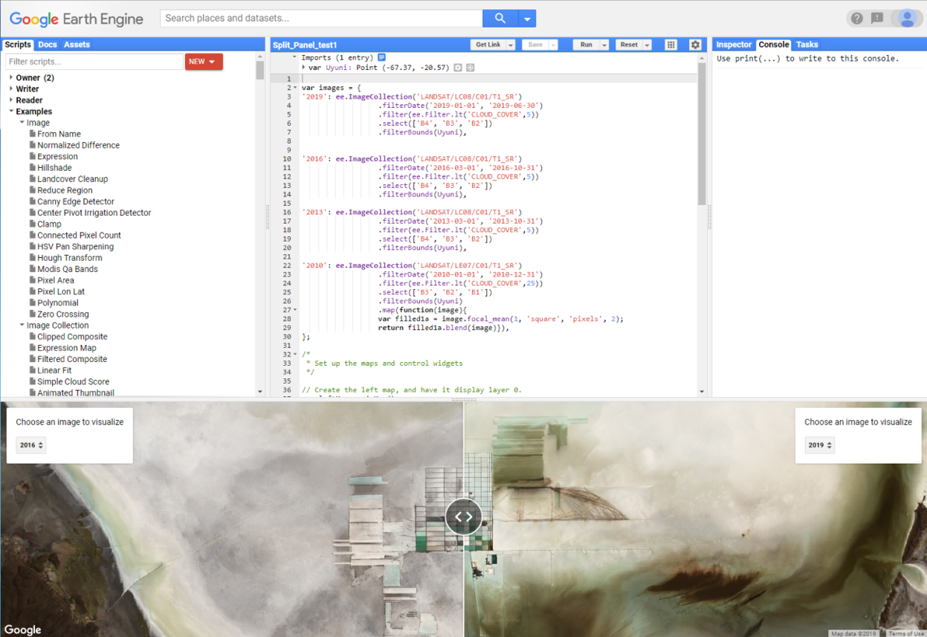
Figure 2. The Earth Engine Code Editor. In the center, an overview of the JavaScript code editor producing a Split-panel of Uyuni. Left control-panel contains code examples and a researchable API reference. Right control-panel has an inspector for querying the map, the output console and a task manager.

Objectives of the Internship
The aim of this work is first to explore how user-friendly this engine is, its power to perform satellite imagery analyses and get to know the interactive tools of this Google Engine. The second objective will then be to test through several case studies the potential of Google Earth Engine to perform fast imagery analysis in our case, oriented into the investigation of two environmental topics:
- Tracing mining evolution-growth with or without deforestation (Chapter 2.1)
- Tracing revegetation post-volcanic eruption or following/during a glacier retreat (Chapter 2.2)

Projects

Tracing Mining Evolution-Growth With or Without Deforestation

Uyuni Lithium Extraction (BOL)

Presentation
There is a global hunger for lithium (Li). This mineral is known to be crucial to power smartphones to electric and hybrid vehicles and to build storage batteries. The world’s largest lithium reserve on Earth is located in southern Bolivia, in the central Altiplano of the Andes at 3’700 meters above sea level.
- Geology of the Altiplano
The Altiplano is located between the eastern and western cordillera of the Andes and it is composed of internally poorly drained intra-volcanic basins. This region was covered during the last glacial stage by large paleolakes. These paleolakes have been drying since the Holocene. In the case of the central Altiplano, these paleolakes have dried into two giant salt crusts: the Salar of Uyuni and the Salar of Coipasa (Figure 3). Sediment cores have revealed alternations of lacustrine episodes and dry periods. A 121m long core extracted in 2001 from the Salar of Uyuni contained 11 lacustrine layers separated by 12 salt crusts (Fornari, Risacher, & Féraud, 2001).
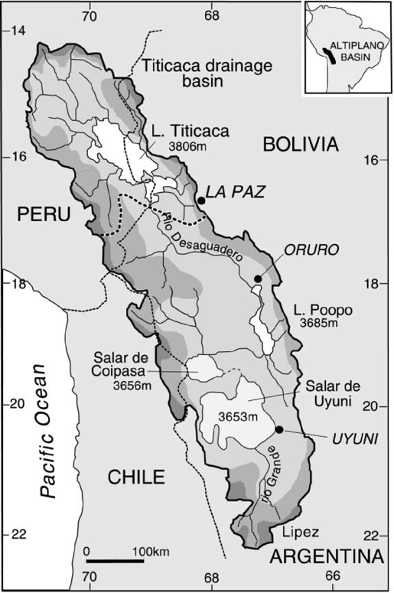
Figure 3. Location of the Uyuni Salar in the central Altiplano drainage basin. North the Titicaca basin (XXX).
- Origin of the Lithium
According to a USGS report Bradley et al., 2013 for producing lithium brine deposits we need:
- arid climate
- closed basin containing a Salar or Playa
- tectonic subsidence
- associated igneous or geothermal activity
- suitable lithium source-rocks
- aquifers
- time to cumulate a brine
A schematic model of the geological setting and mechanisms needed are presented in Figure 4. The Lithium will be liberated by weathering or derived from hydrothermal fluids from the source rocks contained in this basin. Suggested favorable primary source rocks are felsic vitric tuffs (Price, Lechler, Lear, & Giles, 2000). Hofstra et al. 2013 and Arce-Burgoa & Goldfarb, 2009 suggested that the primary source is the nearby rhyolitic tuffs of the Bolivian tin belts located to the eastern part of the Salar of Uyuni. The lithium is leached out over a large time frame from the rhyolite by the meteoric water, drained into the basins and concentrated by evaporation in the local arid environments. The final accumulation of saline groundwater enriched in dissolved lithium is then called a lithium brine deposit.
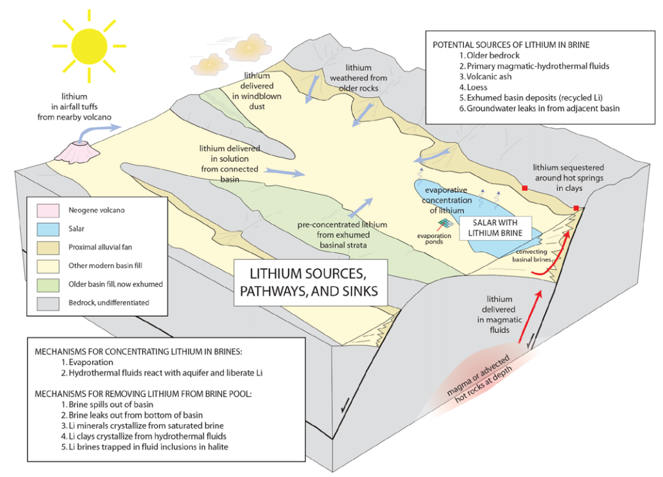
Figure 4. Schematic model of the lithium brines deposits, composed of a closed-basin system with interconnected subbasins. The lowest subbasin containing the Salar (Bradley et al., 2013).
- Extraction
Under the surface lies a blue-green brine enriched with the volcanic lithium, carrying typically 200-1’400 mg/l Li (Bradley et al., 2013). The mineral extraction is performed by pumping brine to the surface. The brine is then stored in a succession of artificial evaporation ponds, on which the Li concentration increases progressively (Figure 5, Chilean San Pedro de Atacama lithium pods). Depending on climate it can take a few months to a year to produce a concentrate of 1 to 2 percent Li. This concentrate is then processed in a chemical plant to yield various end products, as lithium carbonate and lithium metal (Bradley et al., 2013). The Salar of Uyuni holds around 5.4 million tons of the world’s total 11 million.
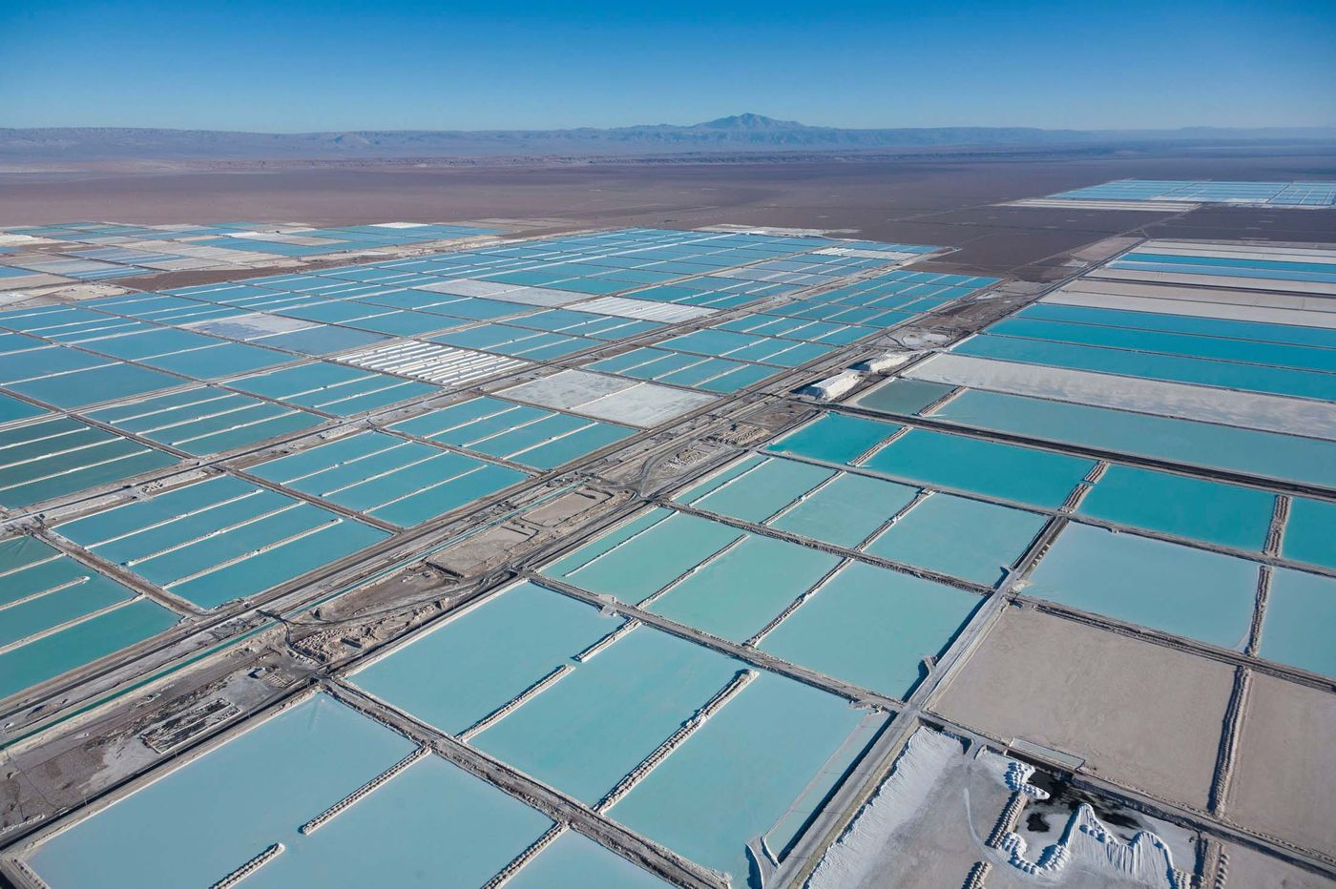
Figure 5. Evaporation pools in San Pedro de Atacama in Chiles for Lithium extraction. Extracted from L. Millan (2018), image by Alamy.

Methods
The methodology applied for all the case studies were developed during the study of Uyuni and Tenke, and the same base-codes were applied for the other case-study. If adaptions (e.g. bands used, cloud masks, etc.) were needed, they are going to be specified in the methodology of each singular case-study.
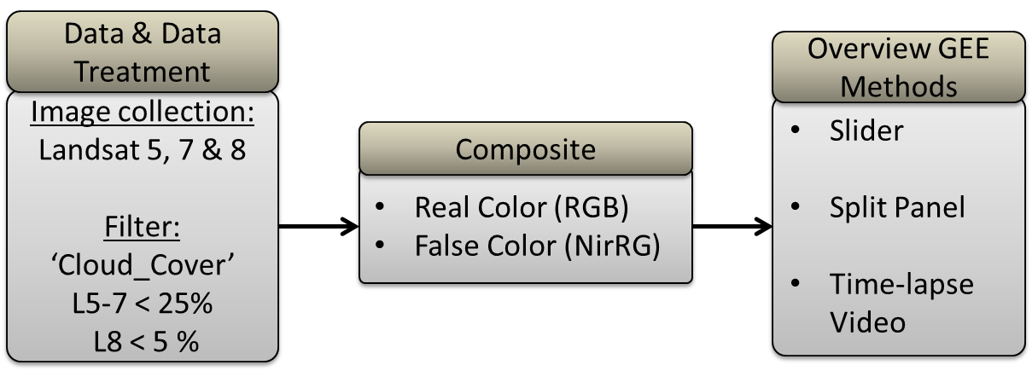
Figure 6. Methodology used for the study case of Salar of Uyuni.
The methods used for this case study are resumed in Figure 6. Landsat images from Landsat 5, Landsat 7 (stripped due to the failure of the Scan Line Corrector since May 31, 2003) and Landsat 8 were used. Simple real color (RGB) composites were used. In a Salar, the salt acts as the snow showing a high reflectance surface. So the visualization range had to be increased up to 8000, which created the best contrast to be able to observe the Lithium mine over the Salar. A cloud filter was used, ‘Cloud_Cover’, which restricts the percentage of clouds that can cover the selected regions (‘.filterBound(), ex: .’filterBound(Uyuni)’, in which Uyuni is a mouse-drawn polygon of the region of interest). When using Landsat 8, the bands were renamed (Figure 7), to be able to merge with the collection on Landsat 5 and Landsat 7. From the merged collection we can then select the needed bands all at once: ex: 'B3', 'B2' and 'B1'.
Three GEE user interface tools were used, the collection slider, the split-panel, and the time-lapses:
- The collection slider from GEE enables to switch between images from a selected period time, so it can switch between weeks, months or years (Figure 8a). The images presented by the slider are a mosaic produced by displaying a median of the collection for each period time, ex. a mosaic per year.
- For a split panel, manually several images for the different periods time are selected. Then a left map and a right map are produced and the control widgets to switch between the different layers of images. As final output, two parallel panels are produced with two singular images (no mosaic). The idea behind is to be able to compare at the same time the variation between two images taken in different moments while moving the division limit button (Figure 8b) and by zooming in or out.

- Time-lapse video is used to run an image collection from a determined period time. After merging the image collection of Landsat 5, 7 and 8, a further collection containing one image per week, month or year can be built. This was performed by creating first a list per period, ex. per year. Second, by creating a mosaic per year using a command called ‘.reduce(ee.Reducer.median())’. Then a final filter cleaning the data was performed. See code extract in Figure 9. Those mosaics are then used for running the video.

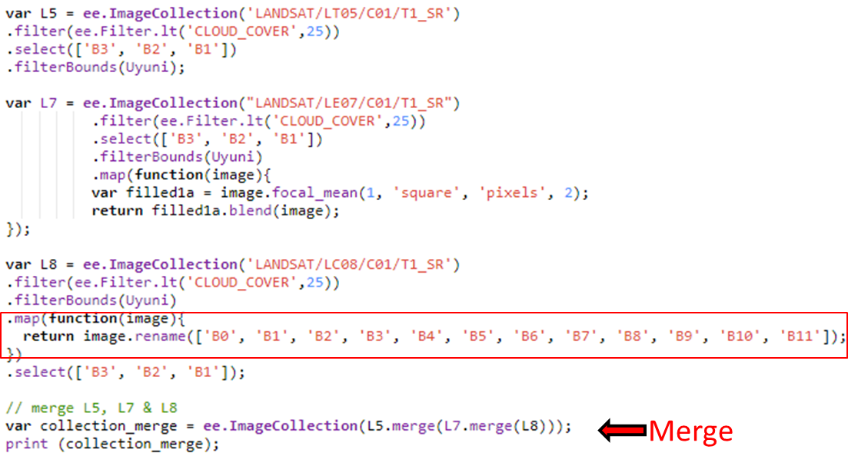
Figure 7. Landsat 8 renaming of the bands and then merging the collection of images from Landsat 5, 6 and 8.
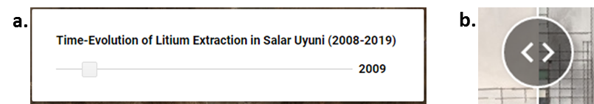
Figure 8. a.) Google Earth Engine annual collection slider for Uyuni. b.) Split-panel button, enabling to move the shown boundary limits of the two images presented simultaneously.

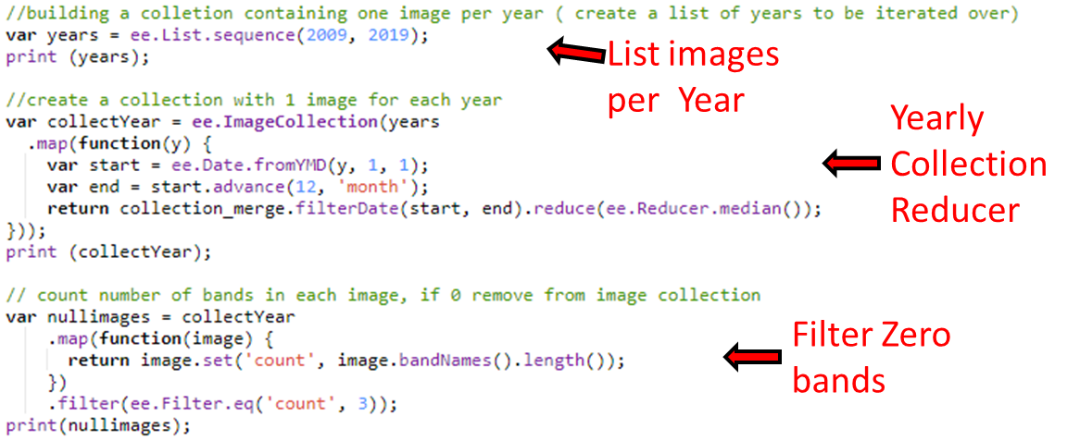
Figure 9. Time-lapse code extract showing the building of the collection per year through listing, then the yearly collection reducer which produces a median mosaic per year and then last, cleaning of the data.

Results
For the case of Uyuni, only real color images were produced as there was no interest in analyzing the vegetation (NDVI, NirGB) or the water (NDWI) variations through time. A slider was used as the first of the GEE presentation tools. It helped to identify the moment at which the extraction of lithium began in the southern part of the Salar and by switching fast between the years the spread by the construction of the pond network through time. The period of interest was identified to go from 2010 until today. In Figure 10 we observe an example for the year 2016 and 2010. However, for the year 2010, some strange composite colors were obtained, which could not be corrected. To compare the variation simultaneously, an image was chosen for 2010, 2013, 2016 and 2019 to produce a split-panel. Figure 10 shows an example for the years 2013 versus 2019.
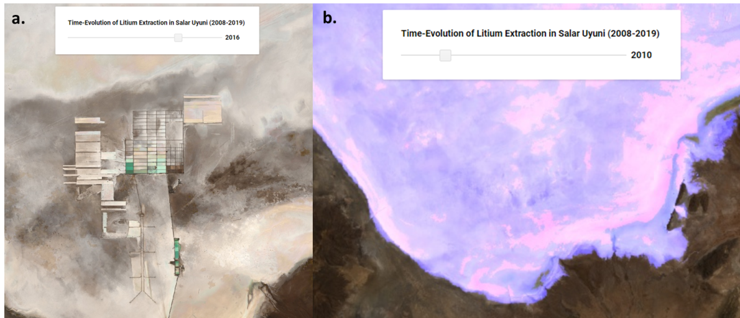
Figure 10. a.) Slider showing the evaporations ponds extends for the year 2016. b.) Slider for the year 2010 presented some strange colors, which were not able to be corrected.
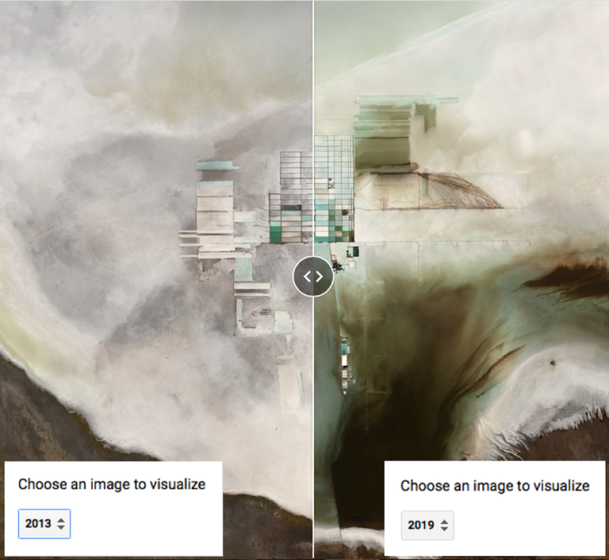
Figure 11. Split-panel for Uyuni, showing the division limit button and the images for the year 2013 versus 2019.
As we are interested to detect through time the spread by the construction of the pond network, an image per year was exported. The resulting variation through time can be observed in Figure 12. The pond network began in the southernmost part, with a singular line, 2011 and 2012 we observe how it expanded to the west and north. The following years the south-western pond expansion seems to disappear and the main and biggest evaporation pond network becomes the northern one, with some extra expansion to the north-western and north-eastern sides. During the year, the use of the ponds varies. The changes in the color of the ponds are showing most probably the evaporation degree and reflects the mayor precipitating minerals (Figure 13). To test if there was a better visualization option, a test using the false-color band combination (NirRG, bands 4-3-2) was performed and is for this case study the best visualization choice (Figure 14).
Finally, a time-lapse video was produced, to test the third interactive way of presenting the image analysis results. A good and nice esthetically talking video can be produced.

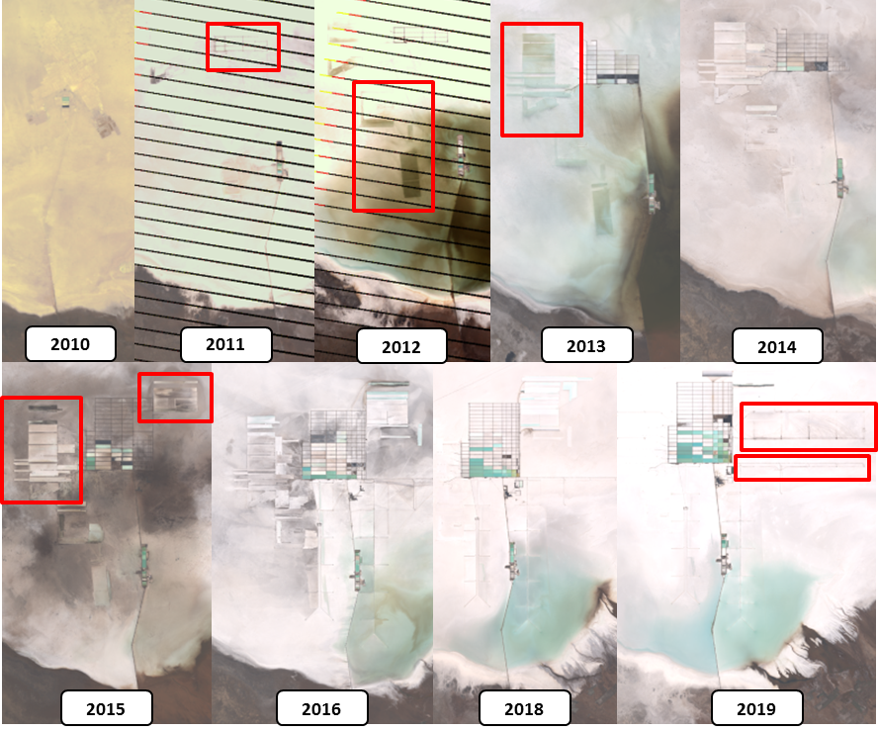
Figure 12. RGB images presenting the spread through time of the pond network.

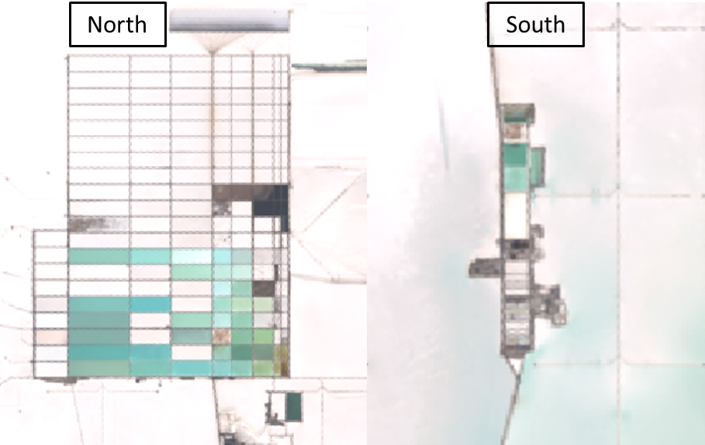
Figure 13. Zoom into the evaporations ponds colors.
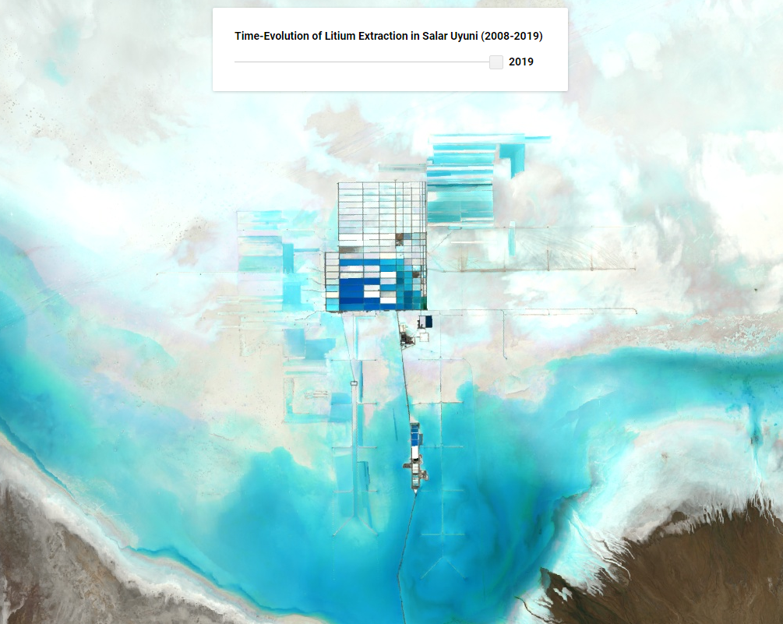
Figure 14. Slider displaying the mosaic for the year 2019 in false colors (bands 4-3-2).

Discussion
According to L. Boissoneault (2015), the Bolivian ex-president Evo Morales gave the permission to open the lithium-production plant in 2013, however, through our satellite imagery, it was recognized that the lithium extraction started already in 2010. This observation points out the great use of satellite imagery. It can be considered as a great register of the past and serve as a great proof for the real changes of the landscape through time. They don’t seem to be illegal ponds, as these seem to be well constructed and continue to be used after 2013.
The three interactive user-friendly tools, Slider, Split-panel and Time-lapses are tools to be used for different steps of the satellite analyses. The slider as first, to identify the variations and the period of interest. The split-panel goes a bit further than just representing two layers of pictures and check/uncheck the layer-box, as it allows us to play simultaneously with the two pictures without charging the picture each time. The switching of picture through layers obliges us to remember the previous image, which is not the most suitable. Therefore, the split-panel can be considered as a great tool to identify precise locations of interest. Finally, the time-lapse video tool should be considered more like a concluding presentation tool, after having determined the precise location and the period of time of interest.

Tenke-Fungurume Mine (DRC)

Presentation
Africa is well known for hosting a high quantity of minerals needed for industrial production, as well as precious metals. The Tenke Fungurume Mine SA (TFM) is located in the south-eastern part of the Democratic Republic of Congo (DRC). This mine is situated within the African copper belt, the Katanga or Shaba Copperbelt. This belt is about 70 km wide and 250 km long. 72 economic cooper/cobalt deposits have been identified in that belt and currently, there are four large mining districts (Laznicka, 2010). This mining district is composed of Sediment-hosted Stratiform Cu-Co deposits. It is one of the largest copper producers in DRC, and one of the world’s largest known copper and high-grade cobalt deposits. The construction of the mine began officially in 2006 and then opened in 2009.
The DRC has the second-largest tropical rainforest in the world, second after the Amazon rainforest (Bwenda, 2008). In Katanga province, the forest that predominates is known as the Miombo or Zambezian woodlands (Figure 15a). F. Malaisse (1997) defines it as “a mixed plant formation with a thin layer of grass species beneath a population of trees between 15 to 20 meters in height; the canopies of the trees, often umbrella-shaped, touch or almost touch, but their foliage is not very dense, which means the area as a whole is well illuminated” (Figure 15b). According to C. Bwenda (2008), after a decade of the civil wars and economic crisis, the population of this region has been cut from the formal economy, and these woodlands are crucial as it provides them with food, medicine, and material of construction (Figure 15c). Mining is considered as one of the principal causes of the gradual shrinking of the woodlands.
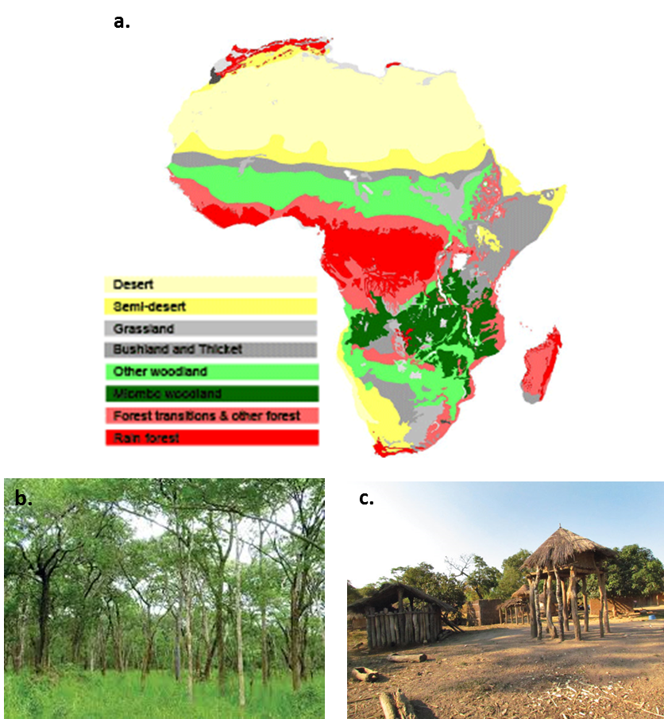
Figure 15. a.) General map of the African vegetation, with the Miombo woodlands in dark-green (F. White, 1983). b.) Web picture from Miombo woodland vegetation. c.) Picture of the use of the trees as construction material. Pictures from C. Geldenhuys (2014).

Methods
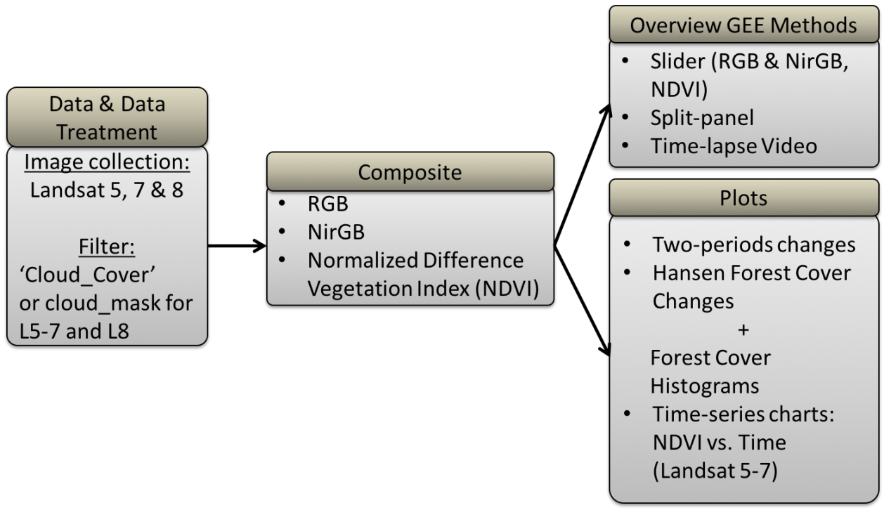
Figure 16. Methodology used for the study case of Tenke (DRC).
The methodology for this study case is presented in Figure 16. For this study, true colors RGB and NirGB composite were performed, as well as multispectral calculations to obtaining the Normalized Difference Vegetation Index (NDVI). NDVI quantifies the vegetation by measuring the difference between the near-infrared and the red light. The near-infrared light is strongly reflected by the vegetation and the red light is strongly absorbed. In GEE there are three ways of calculation presented in Figure 17.
Sliders were produced using as previously the ‘Cloud_Cover’ filter. For the NDVI the pixel_qa band was used for performing the cloud mask, which sometimes worked well for the Landsat 4-5-7 (Figure 18). For the Split-panel and Time-lapse video, the same configuration was used as for of Uyuni.
Aiming to trace the deforestation, images selected from two different periods were compared to identify the changes that have occurred. This was performed by creating a list of images per year. Then the first image of the oldest collection was compared to the first image of the youngest collection, by using the GEE operator ‘.subtract()’. The resulting image was displayed used a palette blanc-bleu-rouge and was each time stretched by 3σ. Best results are obtained when using the Landsat images calibrated top-of-atmosphere (TOA) reflectance (Chander, Markham, & Helder, 2009).
Time-series charts were produced by merging the Landsat satellites collections, then doing a cloud mask and plotting the NDVI values through time.
Hansen Global Forest Change (Hansen, et al., 2013) raster for the period January 1, 2000, to January 1, 2018, were used to calculate the total amount of pixel of lost and gained tree cover for the whole 2008-2018 period and each singular year. This calculation was done by using the bands:
- Loss (loss for the 2000-2008 period)
- Gain (gain for the 2000-2008 period)
- Lossyear (loss for each year, numerated from 1-18, being 1 the year median loss for the year 2000 and the number 18 for the year 2018).
As we are interested in the amount of area lost and gained, the pixels were converted into the actual area. To help compute areas, Earth Engine has a function called ‘ee.Image.pixelArea()’ which generates an image where the value of each pixel is the pixel's area. Multiplying the loss image with this area image and then summing over the result gives us a measure of area. As we are performing statistics in a study area, a reducer is needed to constrain for a maximum amount of pixels (Figure 19). This calculation is based on a tutorial of google earth Documentation (see Earth Engine Documentation web page in the Bibliography.)
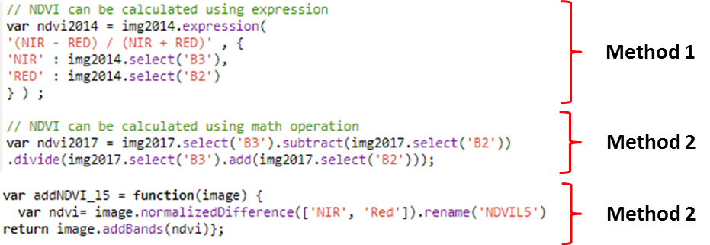
Figure 17. Code extract with three methods for calculating the NDVI.
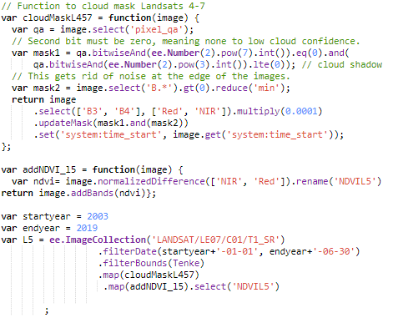
Figure 18. Cloudmask recommended for Landsat 4-5-7 using the pixel_qa band.
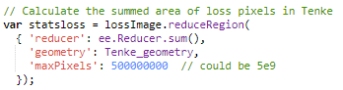
Figure 19. Code extract from the statistical calculation to obtain the amount of area of lost forest in Tenke.

Results
Through the sliders in RGB and NirGB from 2003 to 2019, we observed the beginning of the construction of the mine in 2006 with great excavations until 2009, when the extraction began. Over the next years, the mine expands to the SW growing close to the city of Tenke, as well as SE approaching the bigger city of Fungurume (Figure 20). While the mine was growing, a diminution of the vegetation is observed, but compared to the surrounding areas or the state of the vegetation before the year 2006, it gets clear that the area was suffering already deforestation since a while. Going back to 1984, we see that the area was coved by woodlands, except for the regions surrounding the two cities. For tracing the deforestation since 1984, NDVI’s were created for the year 1984, 2006 (beginning of the mine) and 2019. Then those images were compared/subtracted to identify the variations (Figure 21):
NDVI time-series charts were produced using Landsat 5, 7 and 8. Figure 22 shows the NDVI changes for the period 1984-2019 using the three Landsat image collections. The trendline in red shows a median decrease from 0.352 to 0.325 for these 35 years, which represents a diminution in NDVI of 0.027. However, this seems quite low for the big visual deforestation observed in Figure 21. When excluding Landsat 8 or Landsat 7 from image collection a better result is obtained but still flat with a diminution of the NDVI of 0.034 (Figure 23). Trying with a singular satellite image collection, no good result was obtained with Landsat 5 but a great result was achieved by using Landsat 7 (Figure 24). For the period 1996-2019, with Landsat 7 the trendline shows a decrease from 0.533 to 0.371, so a diminution in NDVI of 0.162, which correlates the best with the visual strong deforestation of that region. The approximate rate of deforestation per year for that 20 years period (1999-2019) is 0.0081 NDVI/year.
Searching to quantify at least partially the deforestation, a quantification of the deforestation in square meters was calculated using the bands loss, gain, lossyear of Hansen Global Forest Change. Figure 26 shows the annual loss of forested area in square meters for the region of Tenke-Fungurume since 2000. It is interesting to observe that before the opening of the mine in 2006, the deforestation was stronger than during the excavation 2006-2009 period of the mine, with some peaks during 2002 and 2003. The beginning of the extraction period of the mine in 2009 strongly correlates with the increase of the deforestation. The highest deforestation year was in 2012 with 40km², low peaks are however also observed, with similar deforestation as before 2006. For the 2000-2018 period, a total of 163’889’841m² of woodlands have been lost in the region.
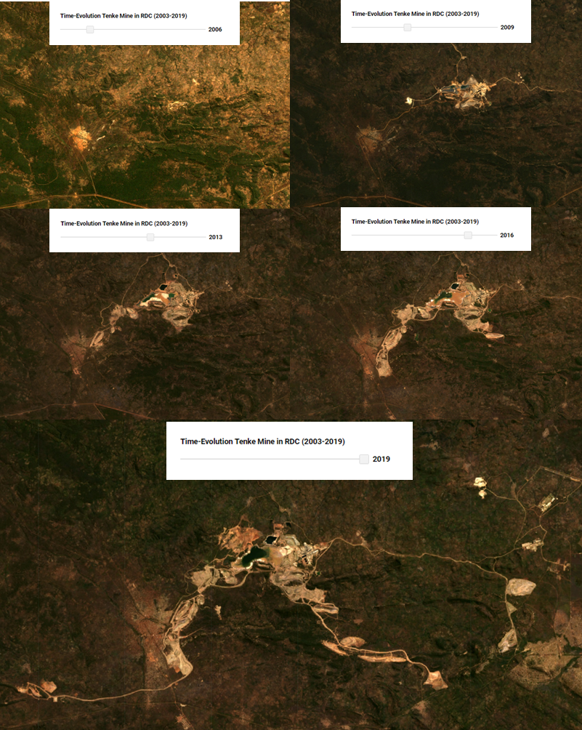
Figure 20. RGB slider showing the expansion of the mine for several years: 2006, 2009, 2013, 2016 and 2019.
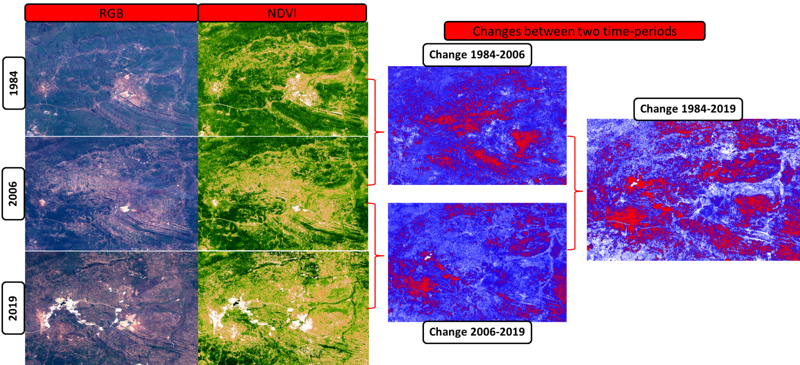
Figure 21. Variations over time. RGB and NDVI images from 1894, 2006 and 1984 and the resulting changes when comparing those periods.
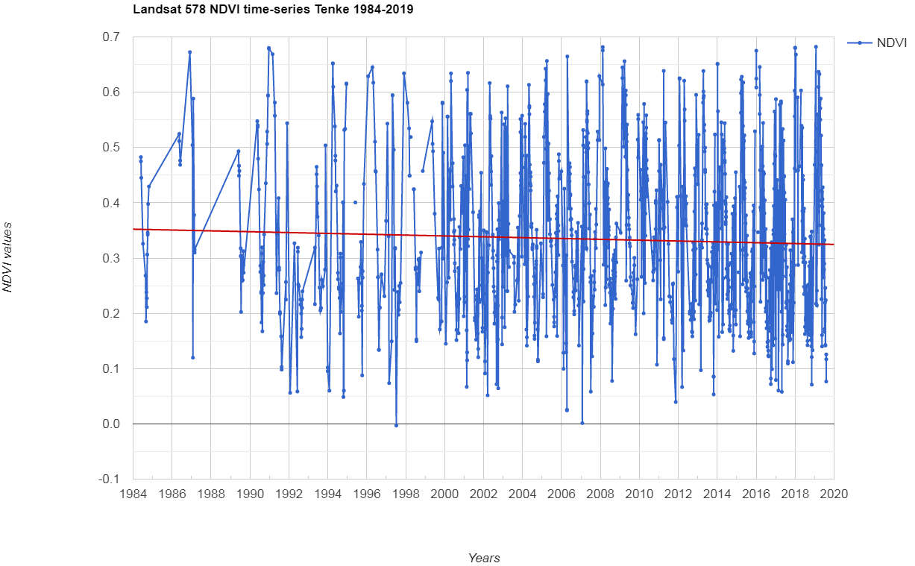
Figure 22. NDVI time-series chart using Landsat 5, 7 and 8 for the period 1984-2019.

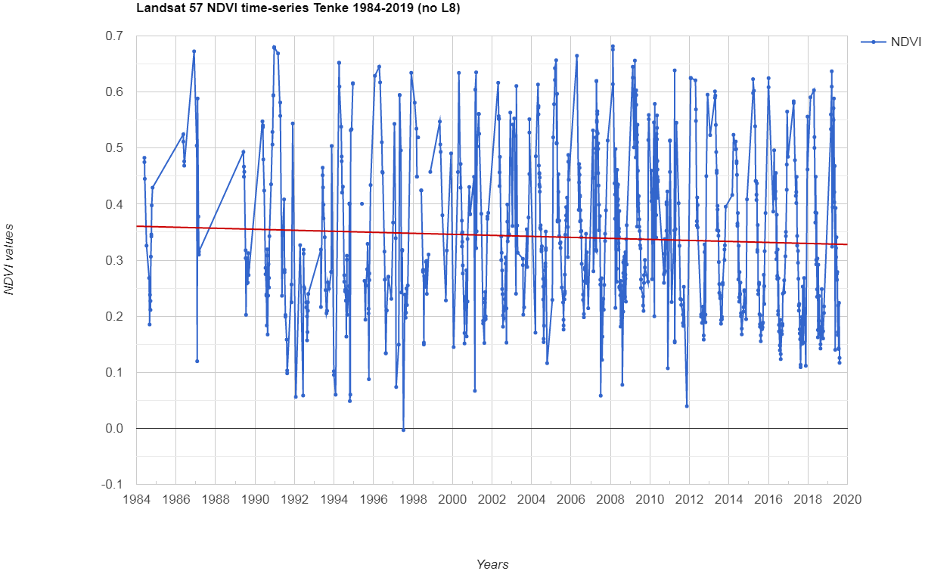
Figure 23. NDVI time-series chart using Landsat 5 and 7. Landsat 8 was excluded to be compared to Figure 22.
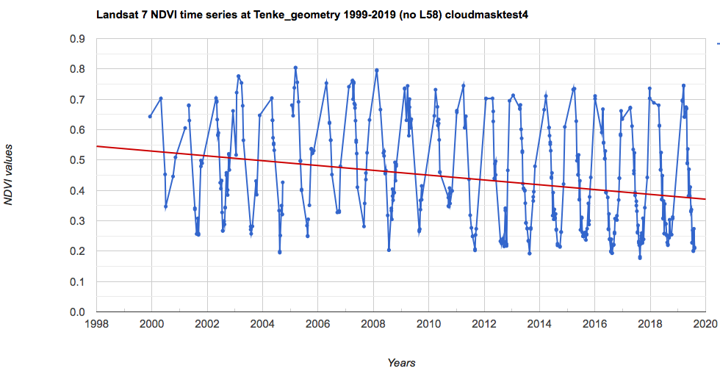
Figure 24. NDVI time-series chart using Landsat 7.

Figure 25. Hansen Global Forest Change for the period 2000-2018. In green we have the tree cover and in red the deforestation. Small blue colors regions should represent reforested areas, but are hardly visible.

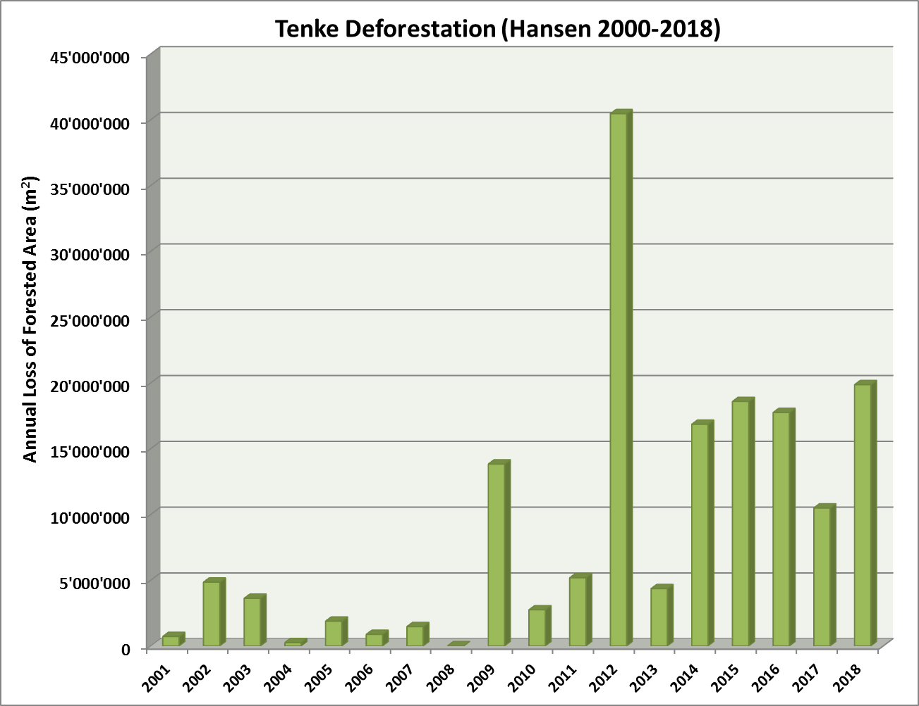
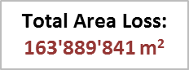
Figure 26. Histogram showing the amount of annual loss of forested area in square meters according.

Discussion
It was interesting to observe through the satellite image analyses that the deforestation of the Tenke- Fungurume region was already happening before the acquisition of the exploration and exploitation rights in 2006. Hansen Global Forest Change helped us to quantify the impact of the mine on the deforestation of this region. Mining activity has occurred in this region for thousands of years, and before the arrival of the mine, there was a large amount of artisanal mining, due to the rise of the copper and cobalt prices. Mining activities are playing a role in the deforestation of the area, mainly for the processing of the minerals, where the smelters are wood-fueled. According to C. Bwenda (2008), the mines in the region of Katanga have spread to listed protected forest zones. Two national parks and fifteen reserves are listed in the regions of Katanga, of which five are in operation. However, the deforestation is also occurring due to other factors, as the image of the changes between 1984 and 2006 reflects (Figure 21). They can be explained by direct causes such as infrastructure development and agricultural expansion or indirect causes like demographic expansion. Nevertheless, agriculture constitutes the main cause, in particular, the slash and burn agriculture. The commercial extraction of wood plays also a large role. It is produced for industrial use as also for the production of charcoal which is mainly for domestic use (Tchatchou, Sonwa, Ifo, & Tiani, 2015).

Gold Mining in Madre de Dios (PER)

Presentation
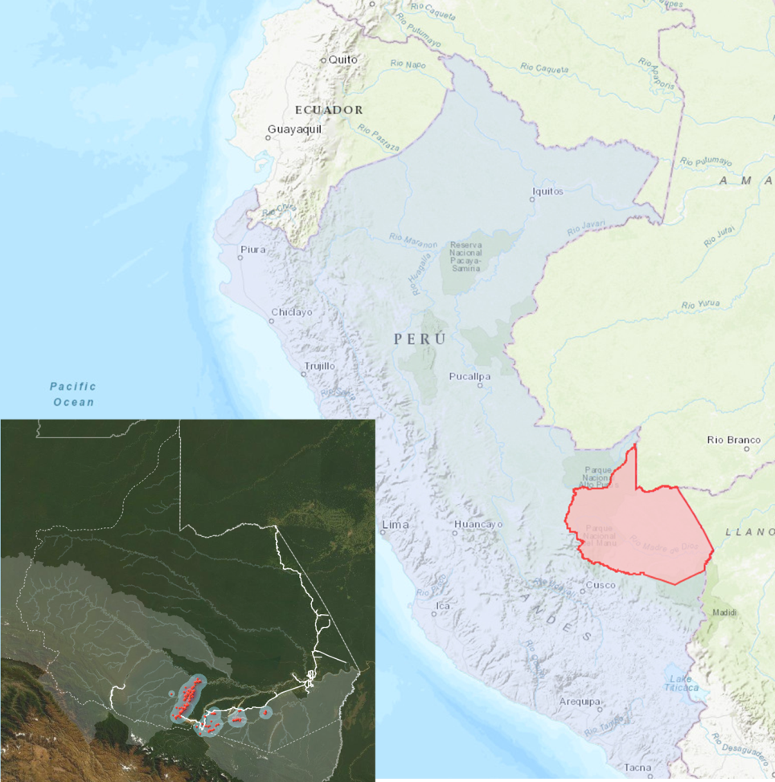
Figure 27. Location of the province of Madre de Dios in southern Peru and a heat map indicating the area in red with the highest concentrations of illegal gold mining (modified from M. Muscoe).
The illegal gold mine of Madre de Dios is located in southern Peru, in the province of Madre de Dios. This illegal gold extraction occurs in the rainforest, near the border with Bolivia and Brazil (Figure 27). This has had a huge impact on the ecosystem, with habitat loss and threats to biodiversity, due to deforestation and also due to the mercury contamination. Liquid elemental mercury is used as the separating agent, and it contaminates the local air and the waterways (Sweson, Carter, Domec, & Delgado, 2011). This deforestation of this area is directly and only due to mining exploitation. Studies have already been performed in this region through satellite imagery (Figure 28), but no quantification was found and therefore will be presented here.

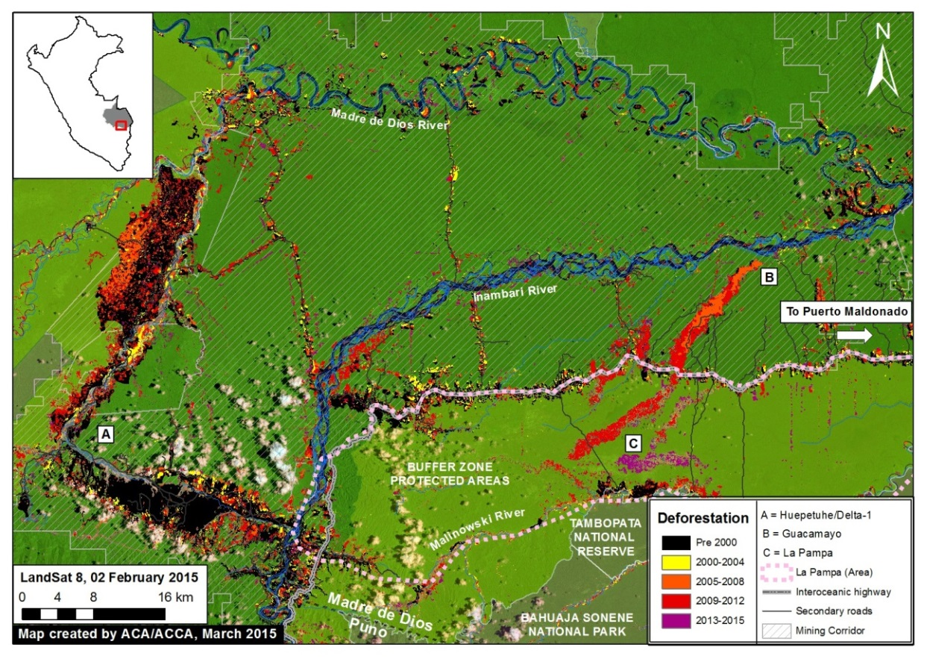
Figure 28. Previous study of the deforestation from before 2000 until 2015 through gold mining (Novoa, 2015)

Methods
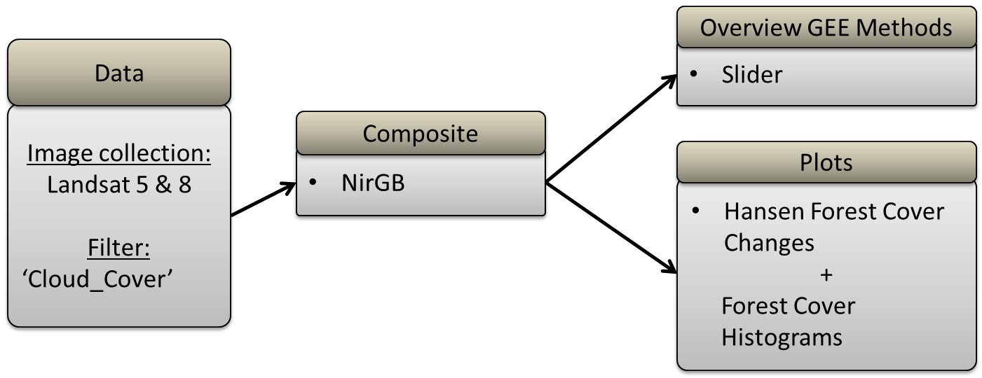
Figure 29. Methodology for the case study of Madre de Dios.
The methodology for this case study is resumed in Figure 29. A slider in false colors (NirGB) was created using Landsat 5 and 8 and the cloud cover filter. Then the Hansen Forest Cover Changes data was used to create histograms of the annual loss of forested area, as in the previous case study.

Results
Using the NirGB slider, the beginning of the mining was traced. No visual difference was observed from 1984-1996. From 1996 to the beginning of the 20th century, the mining began in the south-western part of the Madre de Dios river (Figure 30). A few years later, two new extraction sectors appear along the river area and its evolution process from 2008 until today is presented in Figure 30. When zooming one of these gold extracting sectors, we observe the deforestation and the formation of a landscape of ‘pools’ (Figure 31). This method of extraction consists of creating small pits filled with water and concentrating the gold by performing gold panning with Hg.
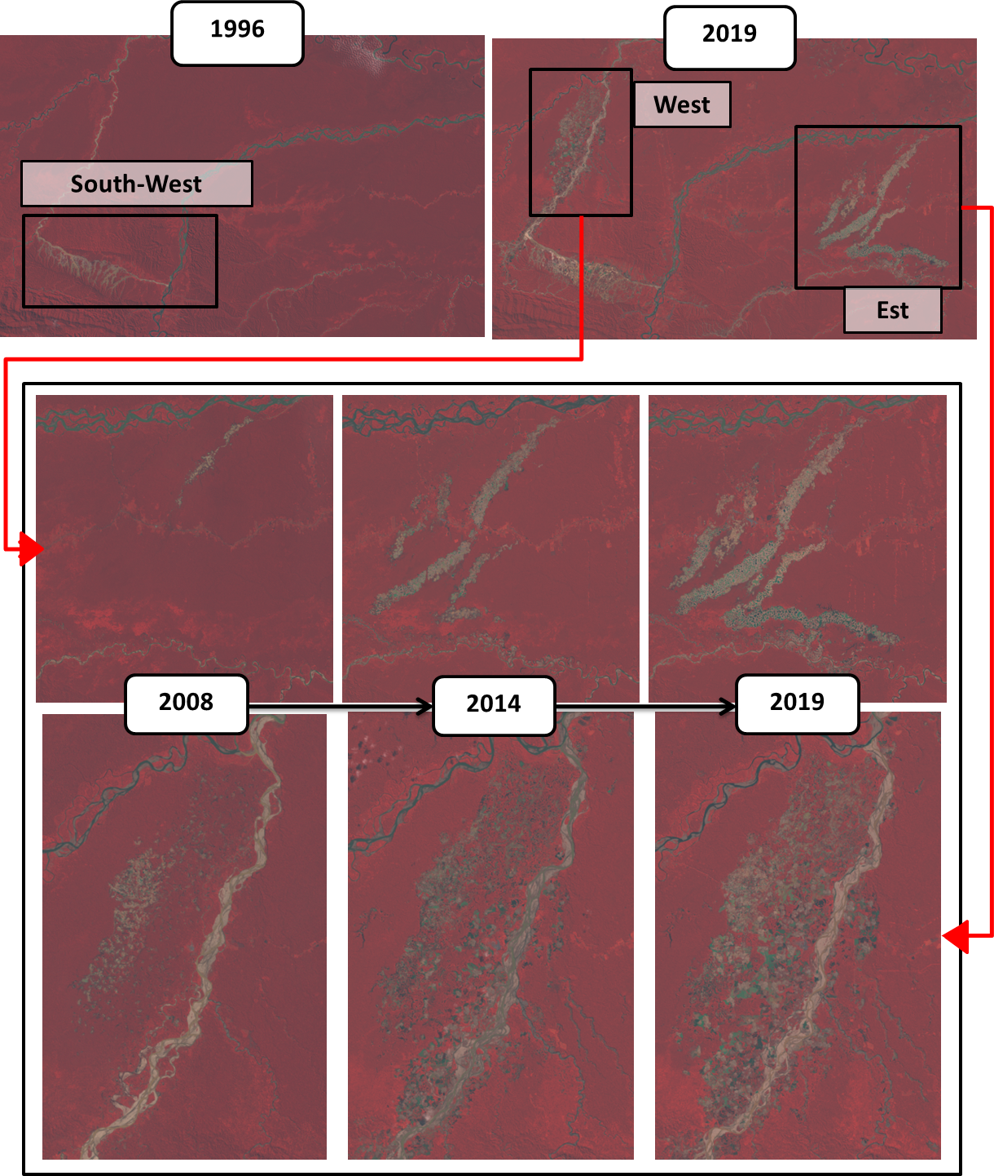
Figure 30. NirGB slider images showing the expansion of the mining are in two sectors of Madre de Dios between 1996 and 2019.
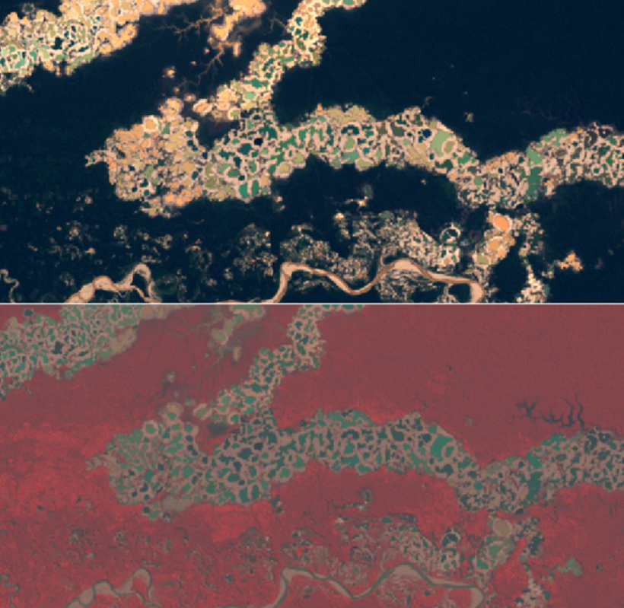
Figure 31. Southern part of the eastern gold mining sector, showing the deforestation for the extraction of gold and the formation of water pools.
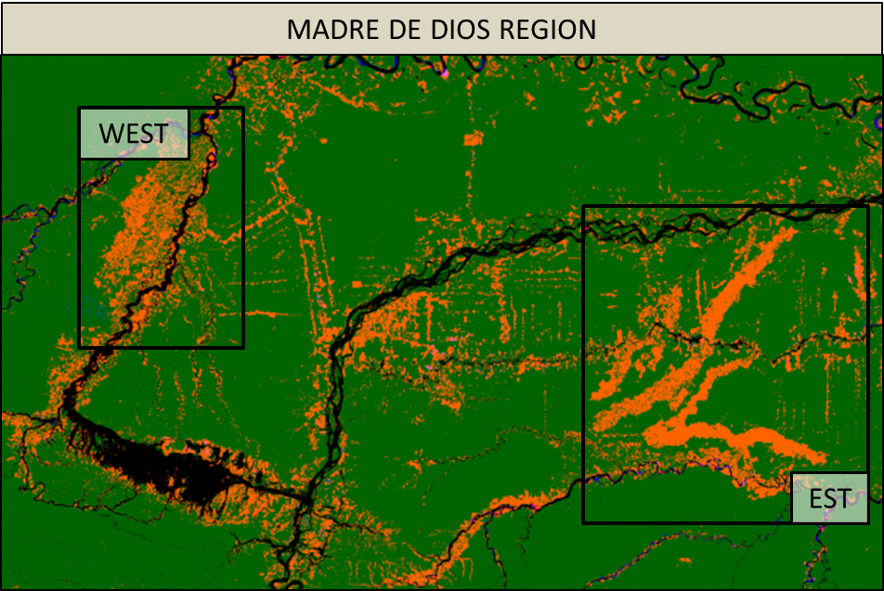
Figure 32. Hansen Forest Cover Changes Map for the 2000-2018 period. In green, we observe the tree cover, in orange de tree loss and in black the river of Madre de Dios.
Figure 32 shows the Hansen Forest Cover Changes map for the 2000-2018 period. In orange, we observe the area that has been deforested during those 18 years. As the main deforestation happed in the western and eastern sectors, the amount of deforestation of those areas was calculated and also of the total region shown in Figure 32. Figure 33 shows the total gain and loss of forested area in the study region, as well as for the western and eastern sector. The total loss is 696’997’210m² versus a gain of 193’691m². Less than half of the loss occurs within the western and eastern sector. When observing at the annual evolution of this deforestation, we see that the region has suffered a trend of exponential deforestation (Figure 34). The eastern sector shows the same pattern, however, the western sector has had some stronger fluctuations since 2006.
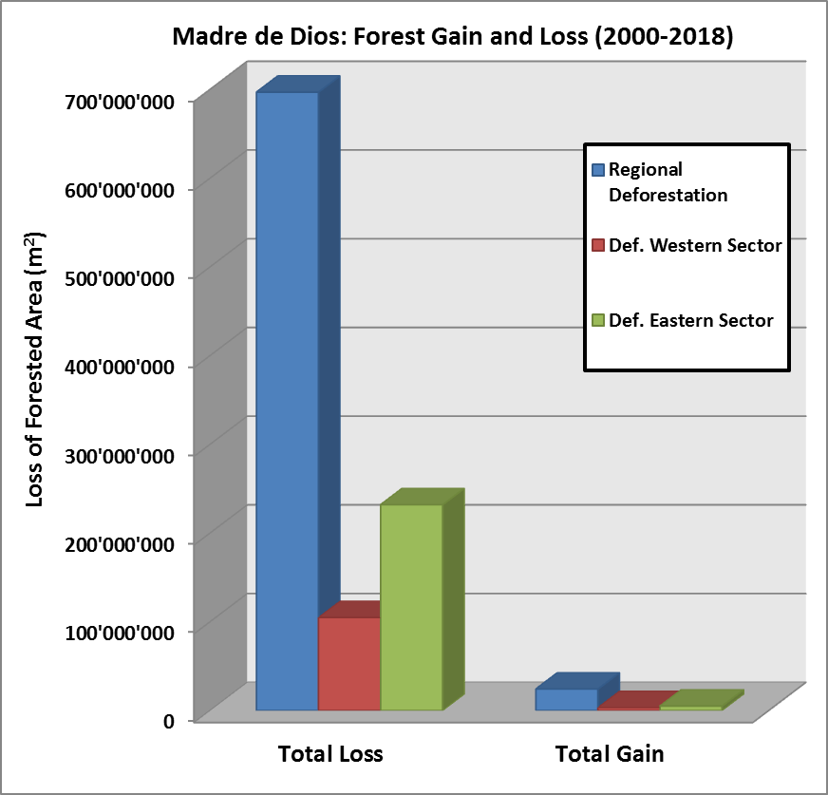
Figure 33. Total loss and gain of forested area in square meters for the region, western sector and eastern sector.
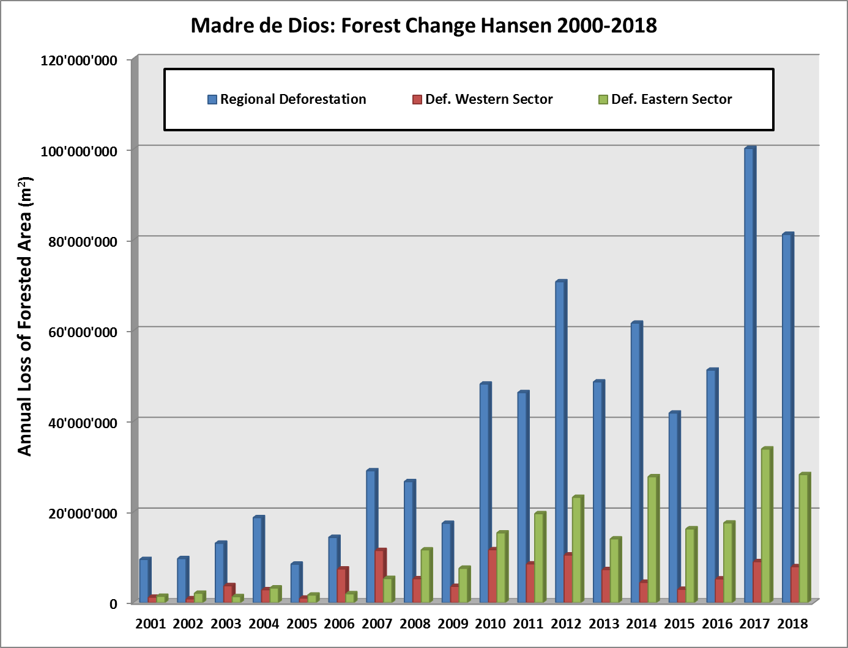
Figure 34. Annual loss of forested area in square meters for the study region, western sector and eastern sector.

Discussion
Although in this case the deforestation was assumed to be due to the gold mining extraction, we again observe that the mining by itself only explains half of the deforestation quantified in that region. This means that the other half has to be the result of other human activities, as infrastructure development and agricultural expansion. Also, the contamination of the water and then of the soil could be an indirect factor decreasing the quality of the soil, which then produces progressively a diminution of the growth of the vegetation in the zone. Those stress condition could have changed the type of vegetation, which could be something interesting to investigate. Even though the deforestation is not only explained by the growth of the mine, the gold in that regions has broth around 30’000 workers to a sector of the Amazonas where the forest was once untouched by the humans.

Revegetation Post-Volcanic Eruption Or By Glacier Retreat

Mt. Etna-IT

Presentation
Having been able to trace the deforestation, the question emerges of how easy is to trace revegetation post volcanic eruptions.
Etna is the largest and tallest volcano in Europe. This basaltic stratovolcano (approx. 3330m high) is located along the eastern coast of Sicily. It is considered as one of the most active volcanoes in the world, with frequent eruptive activity in the summit mouths and also with frequent flank eruptions. Frequently, the idea of considering the volcano as an effusive volcano (mostly emission of lava flows) has changed, as new studies have revealed that the volcano is capable of producing violent explosive activity, like the Plinian eruption of 122 B.C (INGV: Mount Etna Volcano, Sicily, s.d.).
- Geology of the study region
Etna volcano formed at the continental collision zone between the Euro-Asian plate and the African plate (Figure 35). The basaltic type of eruption has been explained by the presence of relaxing tectonics affecting the eastern margin of Sicily, which provoked extension and thinning of the crust. This allowed the magma to rise from the earth’s mantle (Branca, Coltelli, & Groppelli, 2011). The eruptive history of Mt. Etna has been preferentially generated along important fissures distributed in the slopes, known as the North-Est, South and West Rifts (Azzaro, Branca, Gwinner, & Coltelli, 2012). Figure 36 shows a schematic map of the volcanic eruption during the last 2’400 years according to Tanguy et al., (2012).
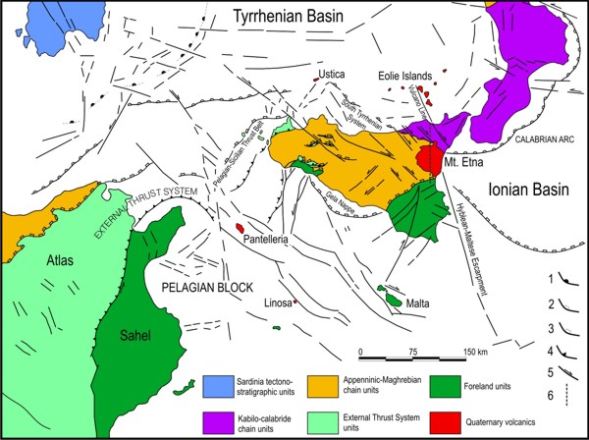
Figure 35. Geotectonic-structural scheme of the Central Mediterranean region with the quaternary Mt. Etna volcano (Branca, Coltelli, & Groppelli, 2011).
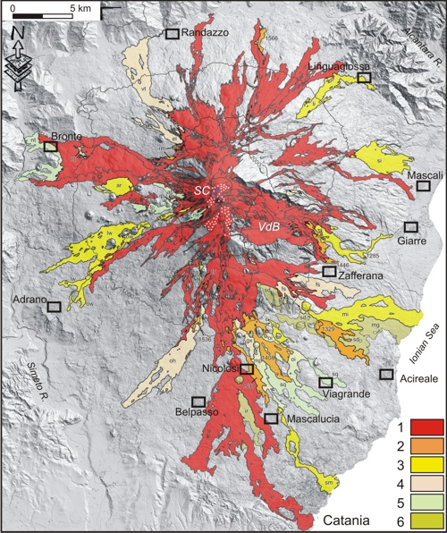
Figure 36. Schematic map of Etna volcanic products erupted during the last 2,400 years (Tanguy et al., 2012). Lava flows and scoria cones during the period of: 1) post-1600 AD; 2) 1300-1600; 3) 1000-1300; 4) 476-1000; 5) 122 BC-476 AD; 6) pre-122 BC. The white dots indicate the 2012 pyroclastic coverage of the summit area. Summit craters = SC; Valle del Bove = VdB.

Methods
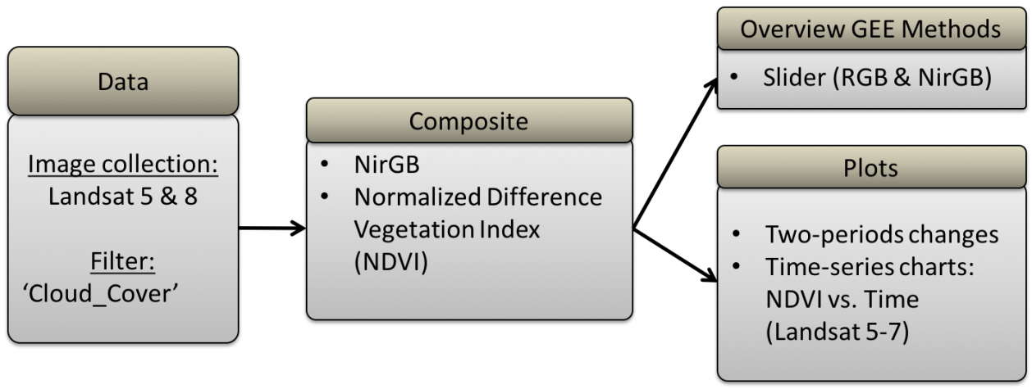
Figure 37. Methodology of the Mt. Etna case study.
Figure 37 presents the resumed methodology for the case study of Mt. Etna. A slider in true colors (RGB) and false colors (NirGB) was implemented as the first approach followed then by the calculation of the NDVI with the production of the two-periods changes images. To finish, NDVI Time-series charts were produced to trace the vegetation growth.

Results
With the slider in true colors, there was no visible vegetation change identified since 1984. As we were aiming to trace the vegetation, a slider in false colors (NirGB) was used, and no vegetation change was visible. However, older and the younger eruptions can be differentiated: the youngest having a dark-black color and the elder ones go to more greyish colors (Figure 38). If no new eruption overlaps, the vegetation should slowly begin to recolonize the area. However, this process is assumed to happen very slowly, needing around a hundred years.
Through the period of 1984-2019 (35 years), two eruptions were identified using the slider and the NDVI- 1987-2019 period changes image (Figure 39):
- the October 2002 to January 2003 eruption originating from the NE rift
- the 1991-1992 eruption in the SE, which was deviated using an earth barrier (400m long, 20m high) and, later one, explosives to blast the lava tunnel, in order to stop the lava of reaching the town of Zafferana (see location in Figure 36).

As visually no revegetation is visible, NDVI time-series charts were used to see if a revegetation process could be identified by plotting the NDVI values from 1984 until 2019 in three regions of Etna (see areas in Figure 40):
- Figure 41 presents the NDVI fluctuation from the whole volcano. A positive trendline was obtained with a median NDVI value in 1984 of 0.238 and in 2019 of 0.316. This represents a difference in NDVI in 35 years of 0.078.
- Figure 42 displays the NDVI fluctuations for the eruption in the West-Rift. As median NDVI value in 1984 of 0.105 and in 2019 of 0.176m, this represents an NDVI difference of 0.071.
- Figure 43 exhibits the NDVI fluctuation for a sector of the previous West-Rift eruption, where the vegetation appears to be more dominant. The results of NDVI for 1984 are of 0.123 and for 2019 of 0.191. The difference between NDVI’s is of 0.068.

Figure 38. False colors NirGB slider highlighting the past eruptions.

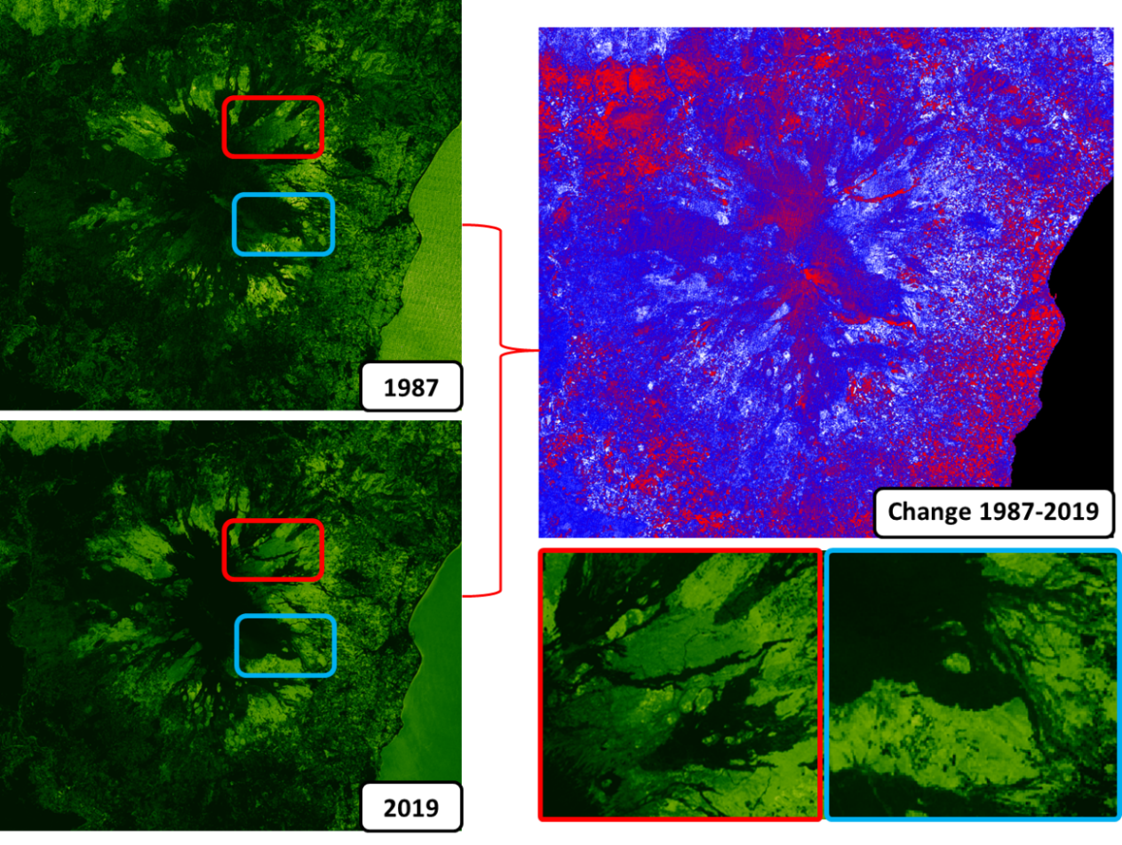
Figure 39. NDVI two-periods changes. Identification of the 2002 eruption in the NE and partially the 1991-1992 eruption in the SE.
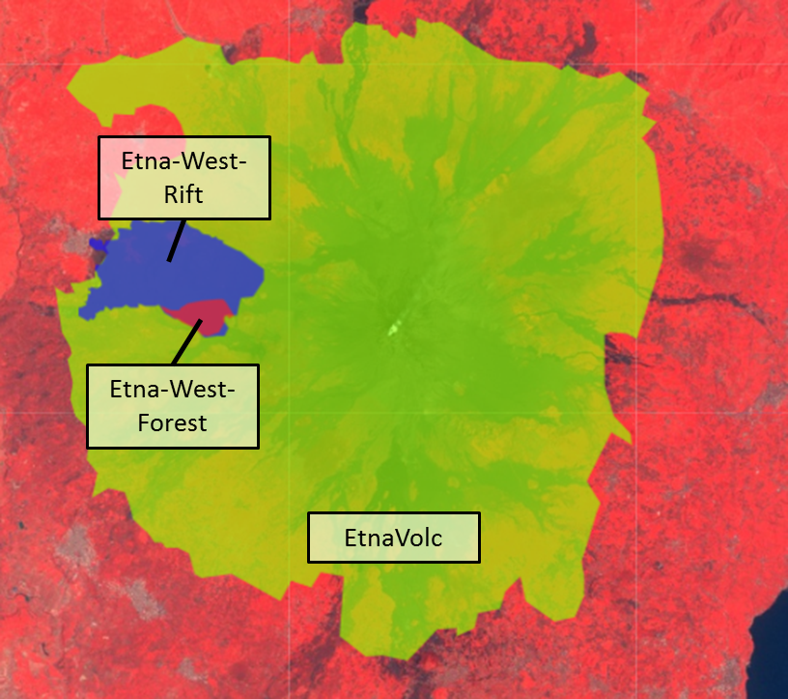
Figure 40. Three zones used to create a NDVI time-series chart.
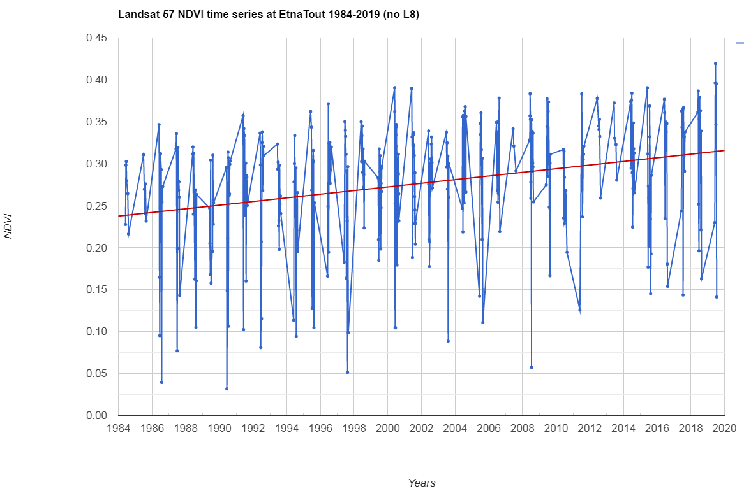
Figure 41. NDVI time-series chart using Landsat 5 and 7 for the whole volcanic edifice.
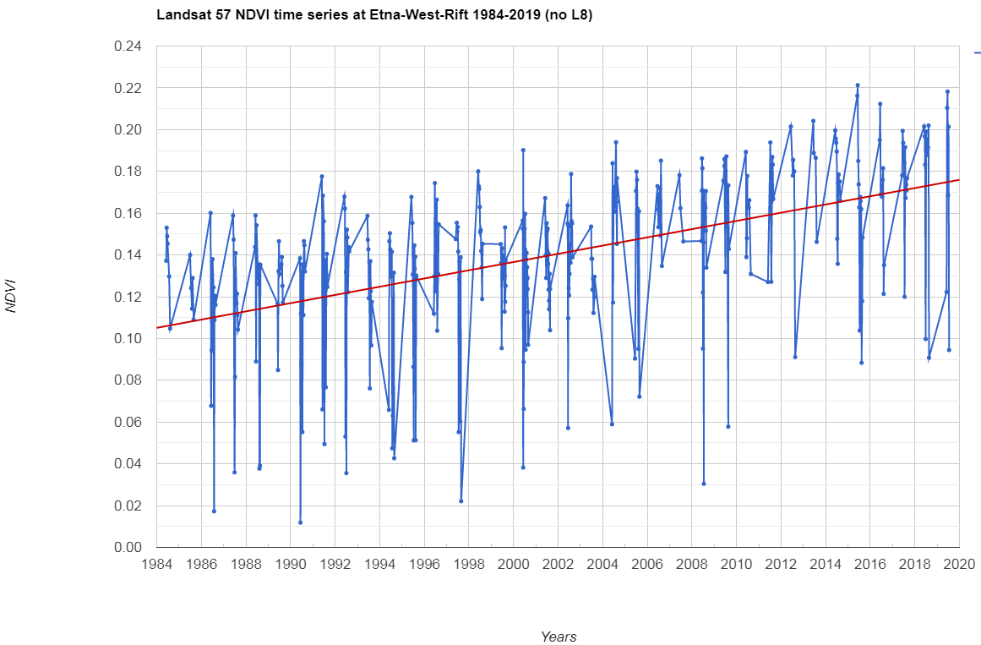
Figure 42. NDVI time-series chart using Landsat 5 and 7 for one big Western Rift eruption.
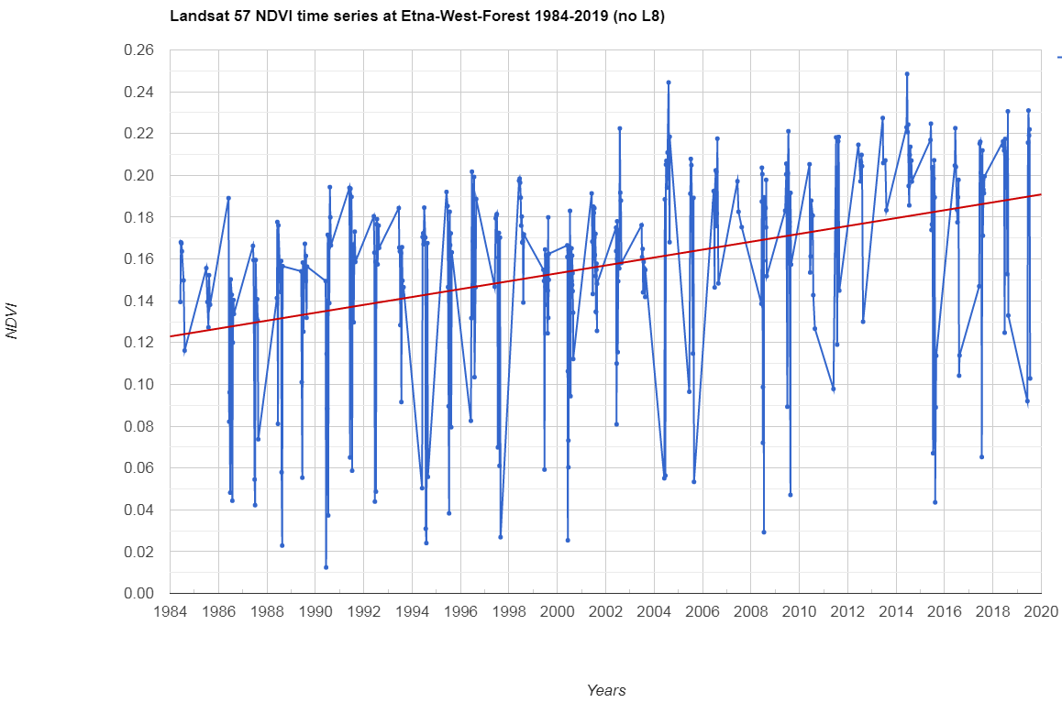
Figure 43. NDVI time-series chart using Landsat 5 and 7 for a more vegetation rich sector of the investigated Western Rift eruption.

Discussion
This case study reveals the utility of time-series to study vegetation-growth. A simple observation of the satellite image is not in all cases useful, and more when the growth of the vegetation is happening at a very slow rate as observed in the NDVI 1984-2019 difference values (0.068 to 0.078) and in a lapse of time of hundreds of years. Those very similar NDVI difference values for a singular eruption as for the whole volcano could suggest a similar median growth rate of 0.002 NDVI per year happening in all the sectors of the volcano. Elder more greyish eruptions could be studied to observe if the rate of vegetation growth gets higher, but some delimitation problems of the eruption limits should be taken into account.

Hunga Tonga-Hunga Ha’apai (TGA)

Presentation
Hunga Tonga and Hunga Ha’apai are small islands situated on the rim of a submarine caldera known by the name of both islands: Hunga Tonga-Hunga Ha’apai volcano. This submarine volcano is located at 45km to the NW of the Tonga capital, Nuku’alofa. The 20th December 2014 a surtseyan eruption under the water occurred. The vent of the eruption is located at the midpoint between both islands (see Figure 44) and added a circular area of new land with 1km of diameter and 100m high above the sea level. This eruption followed 5 years of quiescence of the volcano, the previous eruption having occurred in 2009 (Wunderman, 2015). The deposits of the 2009 eruption were reported to destroy vegetation on the neighboring Hunga Tonga and Hunga Ha’apai islands and added land at the S end of Hunga Ha’apai island.
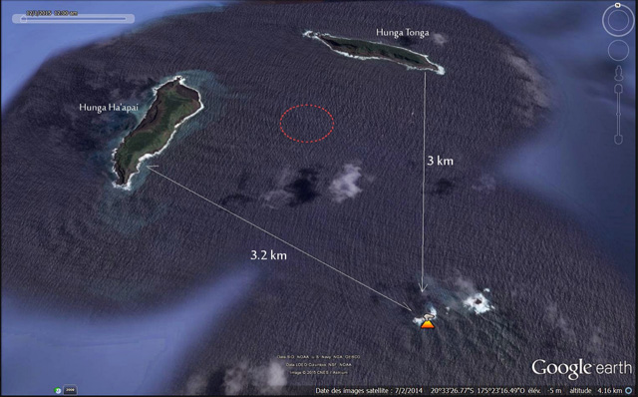
Figure 44. Hunga Tonga-Hunga Ha’apai volcano, with the two Hunga Tonga and Hunga Ha’apai islands located in the margin of the submarine caldera. In red the approximate location of the vent that formed the 2014 volcanic island. Image from Culture Volcan (2015).

Methods
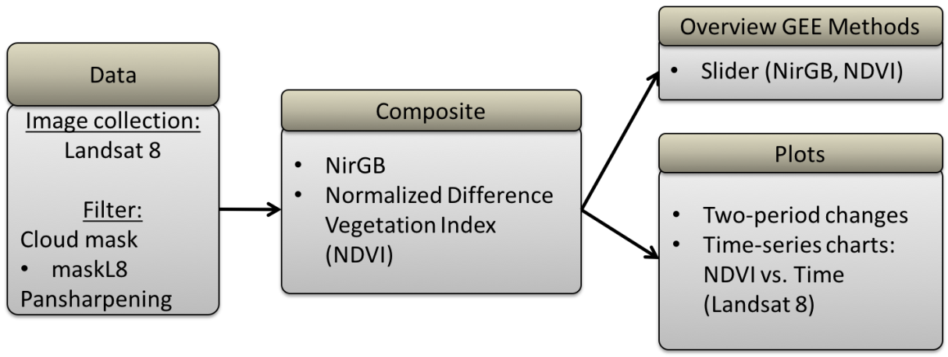
Figure 45. Methodology for the case study of Hunga Tonga-Hunga Ha’apai volcano.
The methodology used for this case study is resumed in Figure 45. NirGB and NDVI sliders were produced to trace the vegetation and the evolutionary growth of the volcano using only Landsat 8. A cloud mask adapted for Landsat 8 was used, as well as an HSV-based Pan-Sharpening of Landsat 8 TOA images to have a better detail of the small-sized islands. Then NDVI two-periods changes images were produced for the periods 2013-2019 and 2015-2019. Finally, to trace the vegetation growth, NDVI time-series charts were done with Landsat 8.

Results
The NirGB slider was used to recreate the state of the area before the eruption of 2014, and to try to recreate the story of the eruption (Figure 46). The eruption lasted less than one month. The suture to the Western side to Hunga Ha’apai is already visible in February 2015. In Mars, the interconnection corridor to Hunga-Tonga island begins. The SE boarder of the new volcano is still partially preserved with its rounded shape. In April 2015, the volcano has sealed with the Hunga Ha’apai island and the eastern corridor continues growing. Figure 47 exposes the appearance of the new island in red and the sealing with both islands.
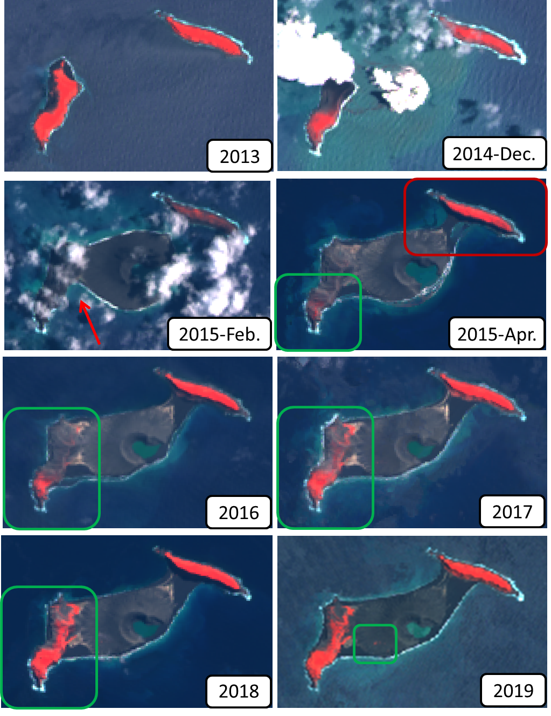
Figure 46. NirGB images extracted from the NirGB slider exposing the pre-eruption state, then eruption, growth and erosion of the volcanic edifice (2013-2019).
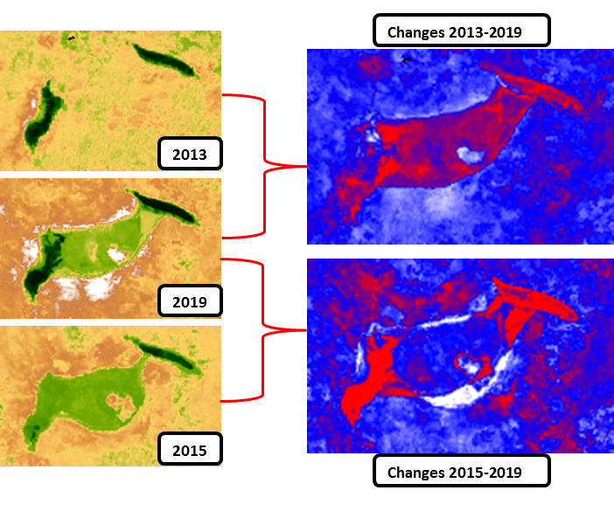
Figure 47. NDVI and two-periods variations. Changes were investigated for the 2013-2019 and 2015-2019 periods.
Following the eruption, we can see that the vegetation of the Hunga-Ha’apai island was strongly affected, mostly in the center and northern sector of the island and in a lower degree the Hunga Tonga island (Figure 46 & Figure 47). When we compare the NDVI image of 2015 and the NDVI image of 2019, we observe a big change of the vegetation. For the case of Hunga-Tonga, the vegetation is back to normal in less than one year. Hunga-Ha’apai island is however still in the process of recovery. To be able to quantify the rate of restoration of the vegetation in the islands and to see if their vegetation is growing in the new island, NDVI time-series were produced for the three islands. Figure 48 shows the area of the polygons used for the time-series. These areas were drawn according to the shape of the islands before the eruption of the new island, to avoid taking into account water.
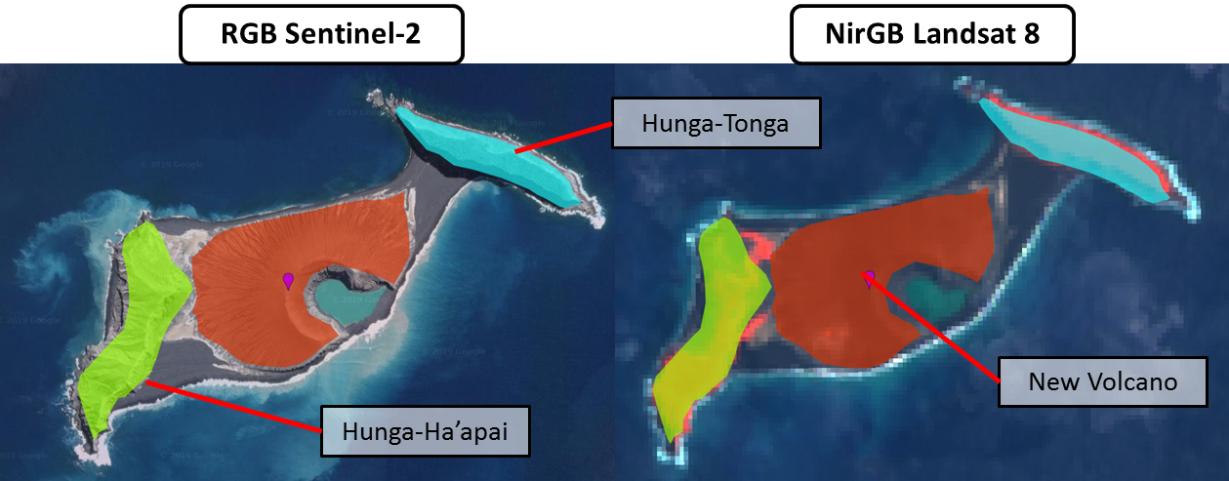
Figure 48. RGB Sentinel-2 image and NirGB Landsat 8 image showing the vegetation extend in red. The polygons were adapted to the shape of the islands before the explosion of the new island.
The NDVI time-series for Hunga-Tonga island shows a drop in NDVI most of the time at the end/beginning of the year (Dec.-Jan.). However, the decrease registered for January 2015 goes down to negative values and during the whole 2015 year, the NDVI values don’t go above 0.4 NDVI (Figure 49). For the year 2016, nature goes back to normal as observed in the NirGB images (Figure 46). The trendline for the Hunga-Tonga island shows an NDVI difference of 0.077 for the period 2013-2019. When only plotted for the post-eruption period (Dec. 2014-2019) the NDVI difference increases slightly to 0.084.
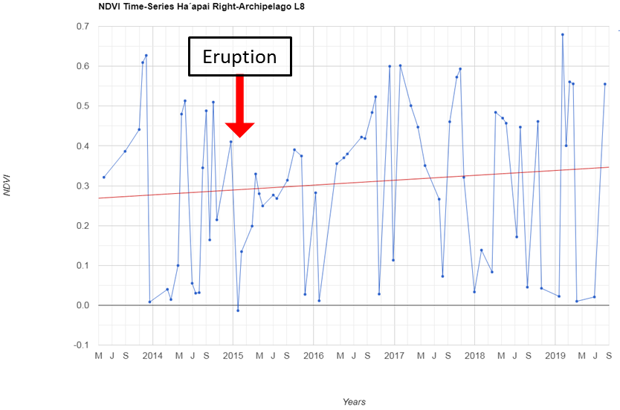
Figure 49. NDVI time-series for the Hunga-Tonga island (Right archipelago).

The NDVI time-series for Hunga-Ha’apai island exhibits (Figure 50) :
- Again at all end and beginning of the years, we observe an NDVI drop (December-January). However, the post-eruption NDVI value decreases down to negative NDVI values around -0.05 (Dec.-Jan).
- During the year 2015, the NDVI values fluctuate slightly but do not go above an NDVI value of 0.4.
- During the year 2016, the vegetation has increased but the NDVI value stays below 0.15.
- During the year 2017, the vegetation continues to recover with NDVI values going up to 0.3. The seasonal fluctuations are more remarkable.
- After 2018, the vegetation is more restored although still increasing but at a slower rate, with NDVI values going up to 0.5. Compared to the NDVI values previous to the eruption, the vegetation of the island is still in a period of recovery. The NDVI values in the island should be able to go up to 0.6 NDVI.
- Figure 51 shows only the time-series for the post-eruption period, the trendline median NDVI value for 2014 is -0.035 and for 2019 0.267. The NDVI difference for those approx. 4.7 years is 0.302. We can then estimate a median growing-rate of vegetation of 0.064 NDVI/year.
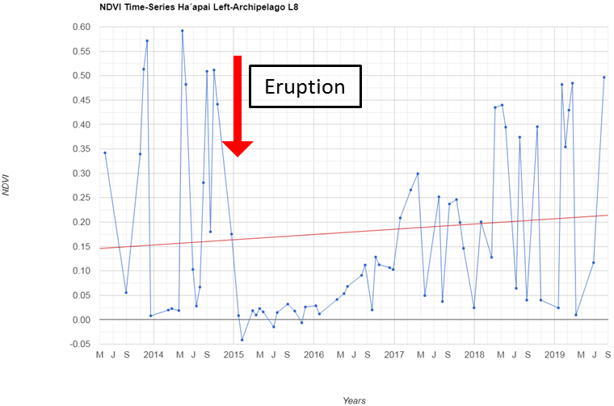
Figure 50. NDVI time-series for the Hunga-Ha’apai island (Left archipelago). Period: 2013-2019
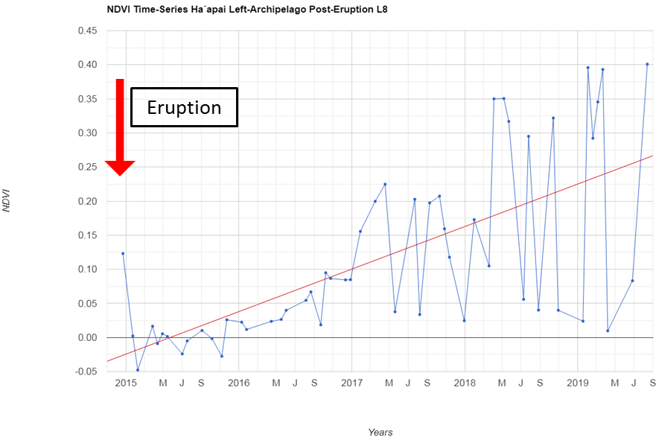
Figure 51. NDVI time-series for the Hunga-Ha’apai island (Left archipelago). Post-eruption period: Dec. 2014-2019

When plotting the NDVI time-series for the new volcanic edifice for the period of December 2014 to 2019, we observe:
- For the total area of the new island, negative values were obtained most of the time, but with the seasonal variation, NDVI values rise up to 0.04. The median NDVI trendline would give a total NDVI difference of 0.068 (min.-0.057, max: -0.034), so a growing rate of 0.0145 NDVI/year.
- For the lower, medium and high slope (or crater) sectors of the volcanic edifice (see areas in Figure 53) NDVI time-series were calculated. Very similar fluctuation trends were obtained along the years, the NDVI differences for each sector are:
- Low slope NDVI difference: 0.068 (Figure 54), so a growth rate of 0.0145 NDVI/year.
- Medium slope and crater NDVI difference: 0.018 (Figure 55 & Figure 56), so rate of 0.0038 NDVI/year.
However, in general, higher NDVI values are exhibit when going to lower slope regions.
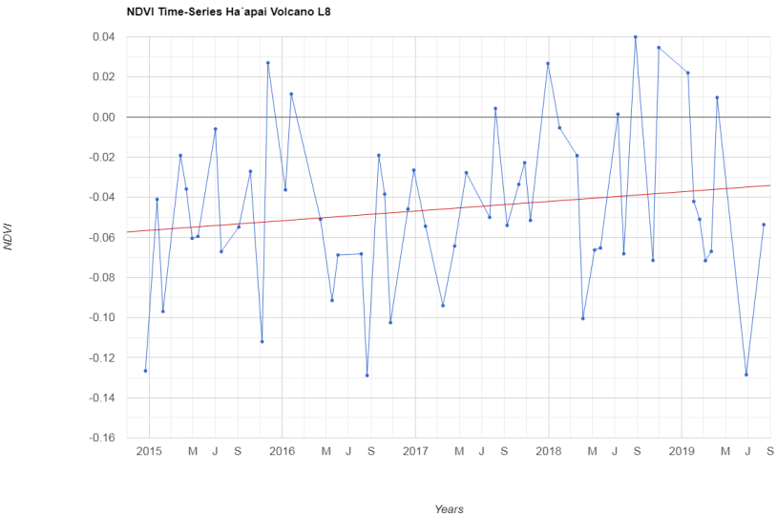
Figure 52. NDVI time-series for the Hunga-Ha’apai island (Left archipelago). Post-eruption period: Dec. 2014-2019

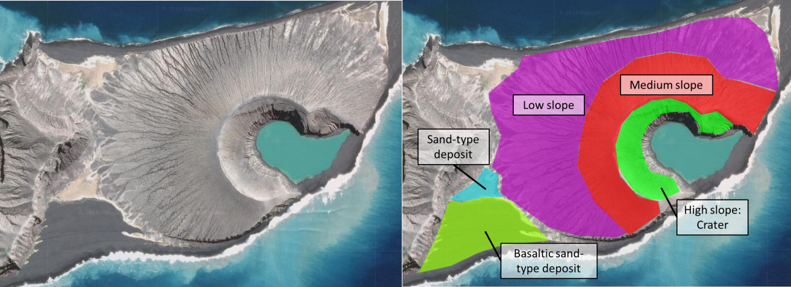
Figure 53. NDVI sectors investigated; low slope, medium slope and high slope sectors of the new volcanic edific, sand-type deposits and Basaltic sand-type beach.
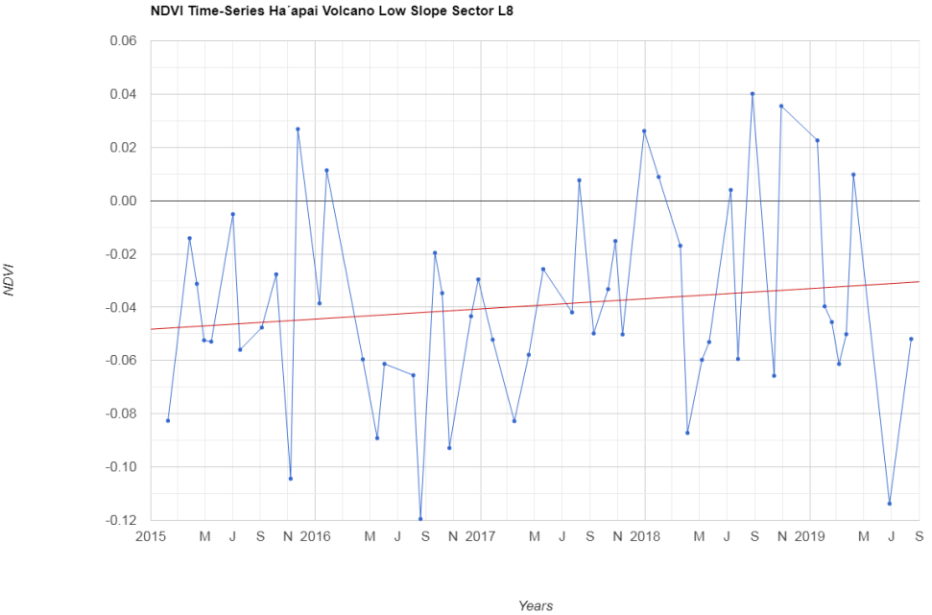
Figure 54. NDVI time-series for the new volcanic island, low slope sector. Post-eruption period: 2015-2019
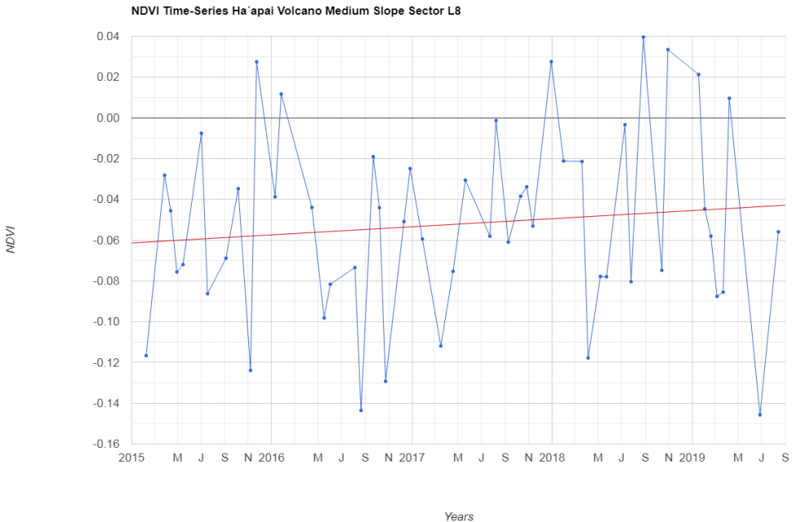
Figure 55. NDVI time-series for the new volcanic island, medium slope sector. Post-eruption period: 2015-2019
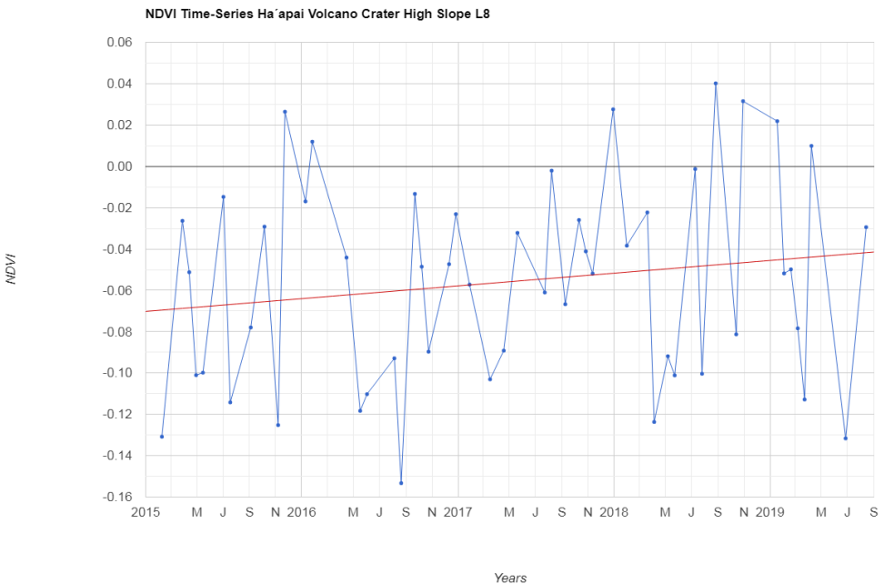
Figure 56. NDVI time-series for the new volcanic island, high slope/crater sector. Post-eruption period: 2015-2019.

NDVI time-series were also performed for sand-type deposits which were accumulated between the new volcano and the islands (Figure 53) :
- For the basaltic sand-type deposits, we have at the beginning very low NDVI values, mostly reflecting the water, as these basaltic “sands” were not yet deposited. These sands originated from the erosion of the southern part of the new volcano. The NDVI values are similar than for the new volcano sectors, with the same maximal NDVI values of 0.04 (Figure 57).
- The scarcer sand-type deposits, however, show a different NDVI trend (Figure 58). Negative NDVI values are observed until November 2015. Then at great speed, the vegetation begins to grow over this sand. The NDVI difference is of 0.207, which represent an NDVI growing rate of 0.044 NDVI/year. Scientifics have recently confirmed that there are signs of life on the island, with flowers and owls (Figure 59).

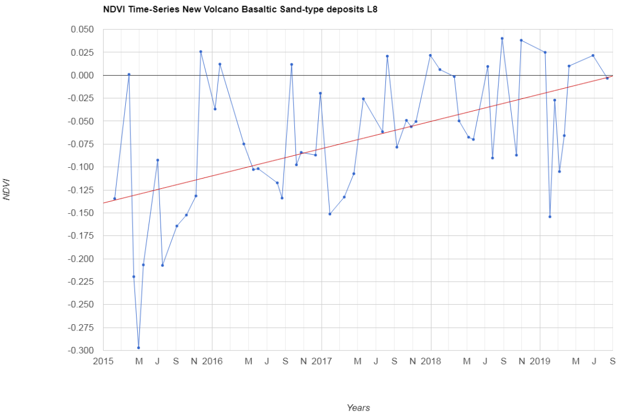
Figure 57. NDVI time-series for the Basaltic Sand-type deposits. Post-eruption period: 2015-2019.
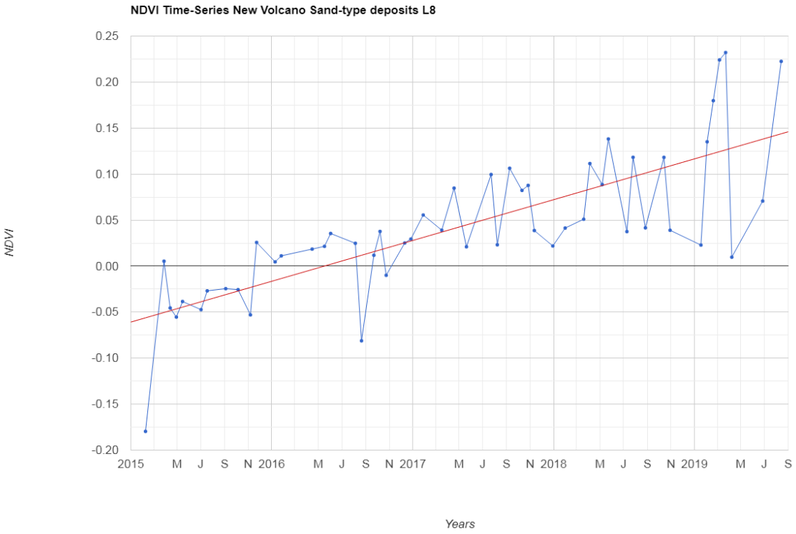
Figure 58. NDVI time-series for the Sand-type deposits. Post-eruption period: 2015-2019.
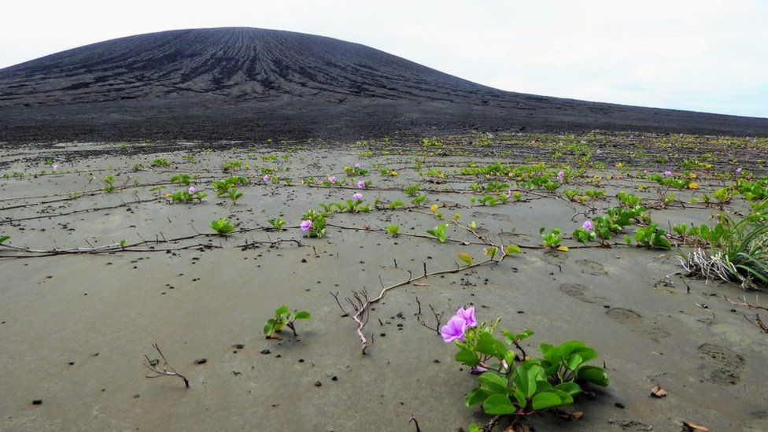
Figure 59. Vegetation on Hunga-Ha’apai and Hunga-Tonga island in the sandy-type deposit. Photograph from DAN SLAYBACK working for the NASA, extracted from (BBC News, 2019).

Discussion
This case study is interesting as we can observe how different is the revegetation process when we compare it to a soil that is partially destroyed or covered by the eruption but has all the biological conditions to reconquer the island, versus the freshly emergent basaltic island with no biological activity. The study gave an approximate estimate for vegetation growth rates for different vegetation states, results are resumed in Table 1. When comparing the destroyed vegetation growth rate of Hunga-Ha’apai with the rate vegetation rate for Etna, we observe a big difference. This is propably explained by the thickness of the volcanic deposits that have been deposited over the vegetation. In Etna, we are talking about 1m to dozen of meters deposited, which means that we are closer to the case of vegetation growth with no vegetation and fresh erupted rock (Table 1, second case). The growth rate is still higher for the case of Hunga, but we cannot forget that we are at different environmental conditions.
Table 1. NDVI delta changes and NDVI growth rate per year for the study case of Hunga-Ha’apai and Hunga-Tonga volcanic eruption in December 2014.
Vegetation State | NDVI delta (4.7 years) | NDVI growth rate (NDVI/year)
Destroyed vegetation | 0.302 | 0.064
No Vegetation, fresh erupted rock + Basaltic Sand type | 0.018 - 0.068 | 0.0038 - 0.0145
Sand-type deposit | 0.207 | 0.044

Rhône Glacier (CH)

Presentation
The Rhône glacier is located in the Swiss Alps, more precisely at the NE part of the Swiss canton of Valais. This glacier is the source of the Rhône river. As almost all glaciers in the world, this glacier has also suffered severs retreats in the last hundreds of years. Landsat images have been used to trace the ice retreat, but no study in our knowledge has been performed concerning the revegetation of the melted and now uncovered areas.

Methods
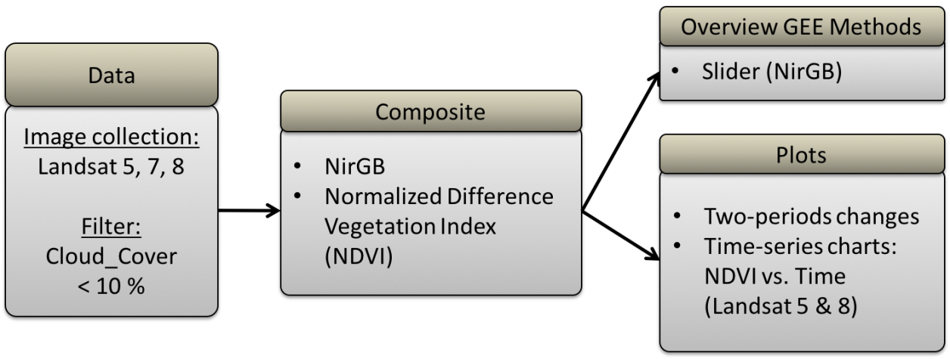
Figure 60. Methodology for the case study of the Rhône glacier.
Figure 60 presents the resumed methodology for the case study of the Rhône glacier. Landsat 5, 7 and 8 were used, with a cloud mask using a cloud cover percentage lower than 10%. A slider in false colors (NirGB) was created to observe the glacier retreat and the vegetation progression. Then, images showing the changes between two periods were produced and NDVI time-series charts using Landsat 5 and 8. Only the period of July to end of August (in some cases September) was used, as it is the summer period. At that moment of the year, we will have the lowest snow cover and the highest amount of vegetation growth.

Results
With the NirGB slider, a big loss in the volume of the glacier is observed from 1985-2019, as well as the creation of a lake at the end of the glacier (Figure 61, RGB images). Looking now at the NDVI images (Figure 61, NDVI images), we observe how there the dominant dark-green color in the year 1984 is replaced by light-green and even yellow coming from the southern part of the glacier, representing higher NDVI values. When comparing the two NDVI images, we recognize in red the total area of glacier retreat.
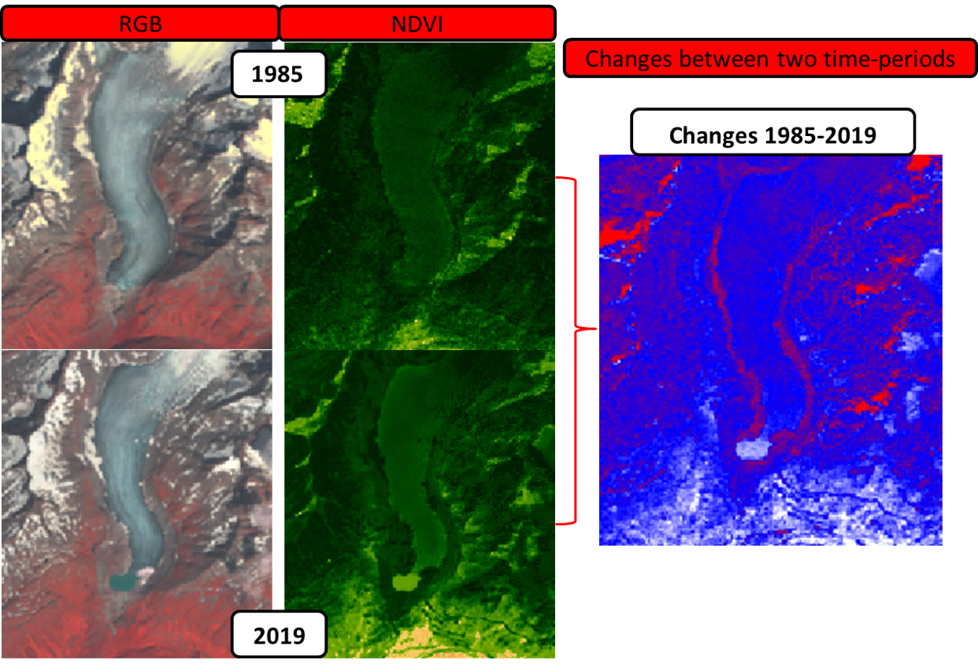
Figure 61. RGB, NDVI images for 1985 and 2019, as well as the 1985-2019 changes image.
To study if these now uncovered areas register a revegetation process, NDVI time-series charts were produced in two sectors (Figure 62):
- An area which was covered in 1984 by ice and is now entirely uncovered.
- An area with no ice cover since at least 1984.

The NDVI-times series charts for the area which was previously covered shows some interesting results (Figure 63):
- Thanks to the chart we can observe the approximate year when this area stopped being cover by the ice, which is in 2004. Before that, the NDVI values were giving negative values.
- Since 2004 the NDVI values have increased up to 0.07.
- Using the plotted trendline, we have an NDVI difference of 0.172, which divided by the 35 years, represents an approximate vegetation growth rate of 0.0049 NDVI/year.

The NDVI time-series charts for the uncovered area shows the following results (Figure 64):
- For the year 1984, we obtain NDVI values that are very near to 0, which could suggest that most of the area in only since a short time uncovered.
- A revegetation process is suggested by the increase of NDVI through time, going up to 0.11 NDVI.
- The trendline suggests an NDVI difference of 0.097. If we divide this by the 35 years, we get an approximate vegetation growth rate of 0.0028 NDVI/year.
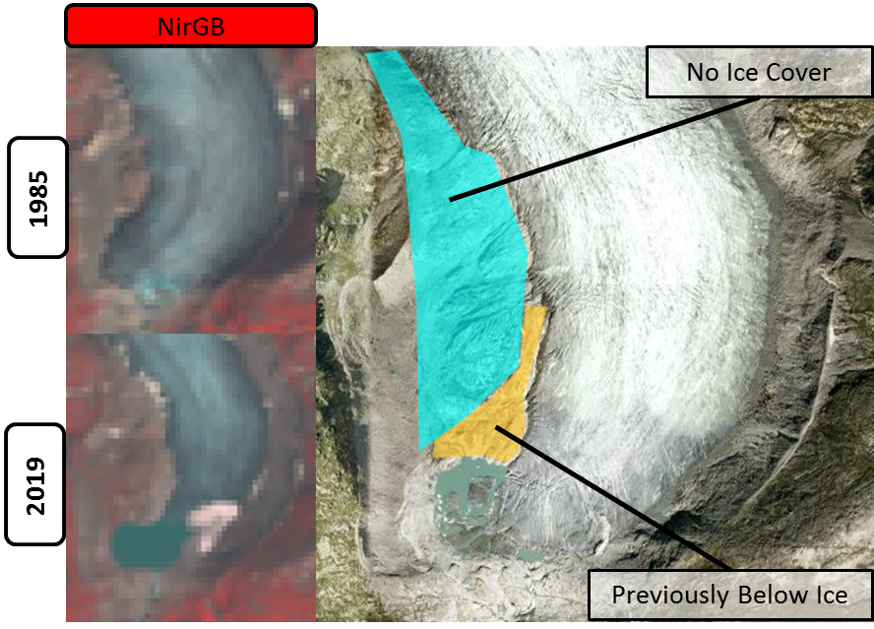
Figure 62. NirGB images of the Rhône glacier and the zones used for the NDVI time-series charts.

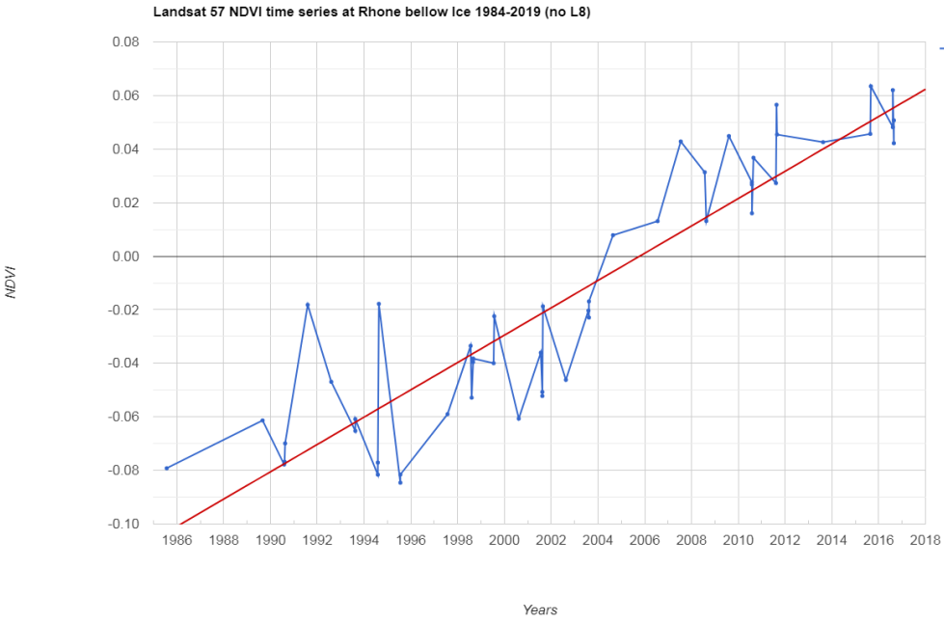
Figure 63. NDVI time-series chart for the sector previously covered by the glacier.

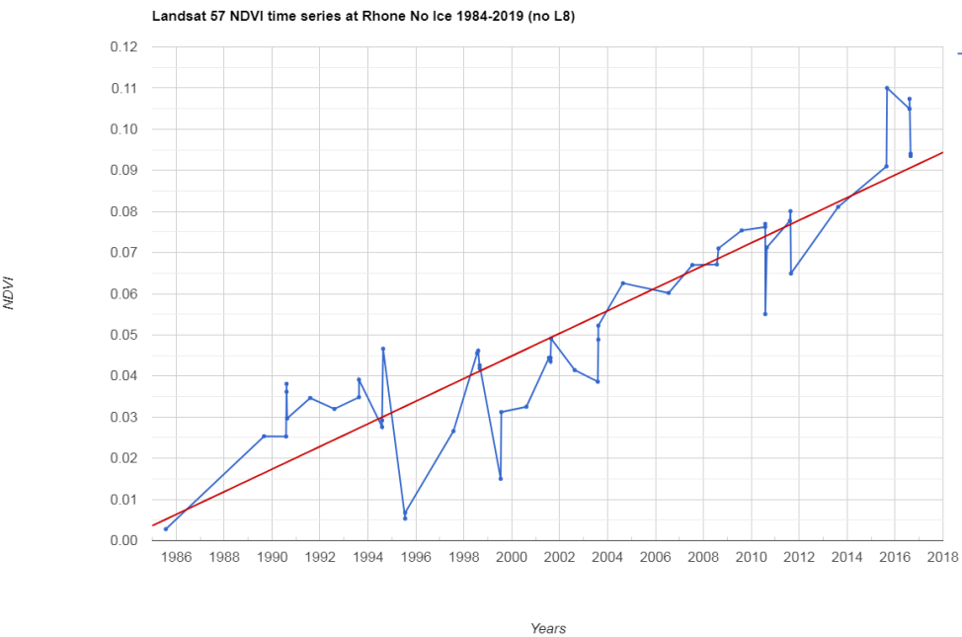
Figure 64. NDVI time-series chart for the sector that uncovered by the glacier since at least 1985.

Discussion
For this case study, as well as for the other case studies, it is important to be cautious with the interpretations, as the NDVI values obtained are giving a mean NDVI value of the total sector. For this precise case study, the NDVI value will be influenced by the ratio of the ice-covered area (negative NDVI) and the uncovered one (positive NDVI if vegetation is growing). Therefore, the most representative rate of vegetation growth would be obtained from sectors freshly uncovered. This area should be previously identified by satellite imagery analysis. Of our both NDVI time-series charts, we could consider the uncovered area results as more precise. Other suggestions could be to perform analyses at similar distances from the glacier, to investigate areas that are uncovered since a similar amount of time, so that have similar growing conditions. This could be another critic to the uncovered and ice-covered NDVI time-series charts.
Now, concerning the approximate vegetation growth rate obtained, values varying between 0.0028-0.0049 NDVI/year are lower or similar to lowest values obtained in areas with no vegetation, due to a growth over freshly erupted rocks.

Conclusion
Concerning the performance of Google Earth Engine, there are various outcomes and comments. The three basic GEE overview tools (Slider, split-panel and time-lapses) gave in general good results. The slider was of the three tools the most useful while beginning to investigate the case study. It can be created very fast if the meteoric conditions in the area are good. Most of the time this was achieved by using the month at which the area has less precipitation, which is also the period with the lower amount of clouds. The Split-panel is a great tool to compare simultaneously two periods without having to switch between the images. The switching of images, as in the slider, obliges the user to memorize the previous image and finally gives only a broad idea of the changes. In the case of the split-panel, it unconsciously forces the user to compare two images in higher detail, by giving as well the option to zoom in/out both at the same time. The time-lapse tool for performing videos was more difficult to use. When one image per year was selected (ex. Uyuni), the date of the image was lost and would then need to be added manually by using some other software. Another time-lapse trial was performed reducing the image collection by choosing the satellite images taken during a certain period of the year (ex: Tenke). In this way, the date could be stored and displayed during the video automatically. However, per year different amount of images were displayed, which makes the video less understandable and also longer. Being fast to use, this tool remains as a great fast performing tool.
For each case study, depending on the sought information three outcomes were produced:
- images resulting from the subtraction of two periods
- Forest Cover histograms by using the Hansen Forest Cover changes data (2000-2018)
- NDVI time-series charts
With the images showing the two-periods changes, the vegetation changes were well-identified for example to study the deforestation in Tenke or Madre de Dios.
The Forest Cover histograms resulting from the calculation of the pixel area for each year, is very useful, as it quantifies the variation. This quantification adds more value to the observed vegetation changes and gives an order of magnitude, either about the vegetation loss or gain, or both. We are however constrained to the period of 2000-2018.
NDVI time-series charts were of great use, mostly for the study of revegetation, but also of deforestation. Areas covered by lava flows or ejecta after a volcanic eruption or areas newly uncovered after the melting of glaciers show no visible vegetation growth at that image resolution. So this “invisible” process can be assessed through NDVI time-series charts. An approximate rate of vegetation growth can be estimated, but any interpretation has to be done with caution. Most caution should be taken when analyzing areas where the surface cover compositions change along the time, as happened in the Rhône glacier, with its progressive ice-melting. The trend line plotted by the GEE engine is neither precise or an accurate way of calculating the growth rate, but gives an approximate idea of what is happening in the region.

Difficulties that can be encountered with GEE:
- Available data on the cloud-based platform is restricted to the one uploaded by Google. However, the possibility to upload data exists.
- Problems encountered with the images can sometimes not be treated, as Figure 10b.
- There are various proposed cloud masks for Landsat 5 and 7, but in some cases, they could not be implemented. Same for the pansharpening. In some cases, even if accepted and no error was reported by the engine, the resulting images were cloudier or no image was reported. The best cloud filter was obtained with the ‘Cloud_Cover’ filter. Depending on the study area and the period of interest, for Landsat 5 and 7 a percentage cloud cover lower then 10-25% was used and gave good results. For Landsat 8 good results were obtained using down to 5% cloud cover.

Regarding the two researched topics, the GEE platform performed well, making possible on one hand, to identify the expansion of mines through time and more importantly, to partially quantify the deforestation caused by the mining extraction. However, for the case study of Tenke, it highlighted that other direct causes are strongly playing a role, such as for infrastructure development and agricultural expansion or indirect causes like demographic expansion. Nevertheless, agriculture constitutes the main cause, in particular, the slash and burn agriculture. On the other hand, it allowed us to trace the low growth-rate of revegetation after a volcanic eruption or after/during a glacier retreat.

To finish, this almost new platform should be considered as a powerful tool for future research investigation projects. It is highly user-friendly and good results can be obtained globally in a short time.

Perspectives
Simultaneously, at GRID-Geneva, Bruno Chatenoux performed a Data Cube on demand for the case studies of Uyuni and Tenke- Fungurume mine. This was the first Data Cube on demand performed at GRID-Geneva and it helped to test its performance.
While producing the Data Cube, some differences were identified compared to GEE. To begin, to create the Data Cube, we had to pre-define the area and the period of interest to download all the available satellite images. For the case of GEE, on one hand, we are restricted to their available data, but on the other hand, all the processing is done globally so we can displace or expand our area of interest at any moment and change as well the timeframe. This also means that one single script can be used for several case studies. However, with GEE, after having selected a timeframe, you are restricted to plot the first image or a mosaic by doing a median, mean, etc., of your image collection. No easy option to switch between the images was identified, which forces you to change manually the timeframe to see all pictures available during that period. With the Data Cub, the images were all downloaded with date and scale after the processing, which enables you to see all the images for the selected timeframe and chose the best ones. While downloading the images from GEE, the date of the picture is not saved and the scale bar is lost. For the scale bar, it seems there are some options to add it (not yet tested), and the date has to be saved by the user.
For the case of Uyuni, some difficulties were encountered with the high reflectance of the salt desert, which was interpreted as clouds and masked when treated for the Data Cube. The problem was solved by using no cloud mask, but this did not represent any problem, as the meteoric conditions for this region are extremely good. In the case of the GEE, this problem was solved by using the stretching options in the configuration panel. It would be interesting to test the Data Cube for the Rhone glacier, where more cloud issues are encountered combined then with the reflectance of the glacier itself.
In general, similar images results can be obtained, but by creating, you own Data Cube, you do not risk any loss of data and if corrections of the data are needed, they can be performed. For a country, having its data is important and essential, as well as to maintain the results private and secure.

Overall Summary of the Internship
This internship at GRID-Geneva was a great opportunity to put into practice and more important to broaden the theoretical knowledge acquired during the courses of the Complementary Certificate in Geomatics at the University of Geneva. With Google Earth Engine, further knowledge was obtained on how to process the different kinds of satellite images (Landsat 5, 7, 8 as well as Sentinel), as they demand different treatments or corrections to obtain the best visualization. Personally, the JavaScript coding language was a great, user-friendly and fast way to learn about programming. Visible and tangible results can be produced with this cloud-free platform.
Another positive aspect of this internship was to be able to work in a department that has a positive impact on environmental governance. It was interesting to see the implications necessary for the production and processing of data that are then used by policymakers.

References

L'activité du volcan Hunga Tonga Hunga Ha'apai a-t-elle changé de style? . (2015, 01 14). Retrieved from Culture Volcan (Journal d'un volcanophile): http://laculturevolcan.blogspot.com/2015/01/lactivite-du-volcan-hunga-tonga-hunga.html
Arce-Burgoa, O. R., & Goldfarb, R. J. (2009). Metallogeny of Bolivia, Metalliferous Ore Deposits of Bolivia (Vol. 79). Society of Economic Geologists.
Azzaro, R., Branca, S., Gwinner, K., & Coltelli, M. (2012). The volcano-tectonic map of Etna volcano, 1: 100,000 scales: an integrated approach based on morphotectonic analysis from high-resolution DEM constrained by geologic, active faulting and seismotectonic data. Italian Journal of Geosciences, 153-170.
Ball, J. (2009). Types of Volcanic Eruptions. Retrieved from Geology.com, Geoscience News and Information: https://geology.com/volcanoes/types-of-volcanic-eruptions/
Boissoneault, L. (2015, August 20). Bolivia Plans to Mine the Salar de Uyuni for Lithium . Retrieved from DAILY JSTOR where news meets its scholary match: https://daily.jstor.org/salar-de-uyuni/
Bradley, D., Munk, L., Jochens, H., Hynek, S., & Labay, K. (2013). A Preliminary Deposit Model for Lithium Brines. USGS.
Branca, S., Coltelli, M., & Groppelli, G. (2011). Geological evolution of a stratovolcano basaltic complex: Mount Etna, Italy. Italian Journal of Geosciences, 306-317.
Bwenda, C. (2008, August 28). Democratic Republic of the Congo: Deforestation of protected areas for mining operations in the province of Katanga – The case of the Basse Kando Reserve. Retrieved from WRM, World Rainforest Movement: https://wrm.org.uy/articles-from-the-wrm-bulletin/democratic-republic-of-the-congo-deforestation-of-protected-areas-for-mining-operations-in-the-province-of-katanga-the-case-of-the-basse-kando-reserve/
Chander, G., Markham, B. L., & Helder, D. L. (2009). Summary of current radiometric calibration coefficients for Landsat MSS, TM, ETM+, and EO-1 ALI sensors. Elservier, 113(5), 893-903.
Earth Engine Documentation. (n.d.). Retrieved from Sites Google: https://sites.google.com/site/earthengineapidocs/tutorials/global-forest-change-tutorial/reference-guide
Fornari, M., Risacher, F., & Féraud, G. (2001). Dating of paleolakes in the central Altiplano of Bolivia. Elsevier Science, 172, 269-282.
Geldenhuys, C. J. (2014, July 23). FORESTRY IN AFRICA: Sustainable use of Miombo woodlands. Retrieved from SA Forestry online: http://saforestryonline.co.za/articles/natural_forests/sustainable_use_of_miombo_woodlands/
GRID-Geneva. (n.d.). UNEP-GRID. Retrieved from https://unepgrid.ch/en/
Hansen, M. C., Potapov, P. V., Moore, R., Hancher, M., Turubanova, S. A., Tyukavina, A., . . . Townshend, J. R. (2013). High-Resolution Global Maps of 21st-Century Forest Cover Change. Science.
Hofstra, A. H., Todorov, T. I., Mercer, C. N., Adams, D. T., & Marsh, E. E. (2013). Silicate Melt Inclusion Evidence for Extreme Pre-eruptive Enrichment and Post-eruptive Depletion of Lithium in Silicic Volcanic Rocks of the Western United States: Implications for the Origin of Lithium-Rich Brines. Economic Geology, 1691-1701.
INGV: Mount Etna Volcano, Sicily. (n.d.). Retrieved from INGV Sezione di Catania, Osservatorio Etneo: http://www.ct.ingv.it/en/volcanoes-etna.html
Laznicka, P. (2010). Giant Metallic Deposits: Future Sources of Industrial Metals. Springer.
Malaisse, F. (1997). Se nourrir en forêt claire africaine: Approche écologique et nutritionnelle.
Millan Lombrana, L. (2018, December 3). Bolivia’s Almost Impossible Lithium Dream. Retrieved from Bloomerg: https://www.bloomberg.com/news/features/2018-12-03/bolivia-s-almost-impossible-lithium-dream
Muscoe, M. (n.d.). Illegal Gold Mining in Madre de Dios, Perú. Retrieved from Arcgis, Story map. Geography 167.
New Tonga island 'now home to flowers and owls'. (2019, February 7). Retrieved from BBC News: https://www.bbc.com/news/world-asia-47153797
Novoa, F. M. (2015). Gold Mining Deforestation Continues to Expand in La Pampa (Madre de Dios, Peru). MAAP.
Price, J. G., Lechler, P. J., Lear, M. B., & Giles, T. F. (2000). Possible volcanic source of lithium in brines in Clayton Valley, Nevada. , Geology and ore deposits 2000—The Great Basin and beyond: Geological Society of Nevada Symposium, (pp. 241-248).
Sweson, J., Carter, C., Domec, J.-C., & Delgado, C. (2011). Gold Mining in the Peruvian Amazon: Global Prices, Deforestation, and Mercury Imports. PLoS ONE, 6(4).
Tanguy, J. C., Condomines, M., Branca, S., La Delfa, S., & Coltelli, M. (2012). New archeomagnetic and Ra-226-Th-230 dating of recent work for the Geological map of Etna volcano. Italian Journal of Geosciences, 241-257.
Tchatchou, B., Sonwa, D. J., Ifo, S., & Tiani, A. M. (2015). Deforestation and forest degradation in the Congo Basin, State of knowledge, current causes and perspectives. Center for International Forestry Research, Occasional Paper 144, 46.
White, F. (1983). The Vegetation of Africa; a descriptive memoir to accompany the UNESCO/AETFAT/UNSO vegetation map of Africa.
Wunderman, R. (. (2015). Global Volcanism Program. Report on Hunga Tonga-Hunga Ha'apai (Tonga). Smithsonian Institution. Retrieved from https://doi.org/10.5479/si.GVP.BGVN201501-243040.
Würsch, L., Hurni, K., & Heinimann, A. (2017). Google Earth Engine Image Pre-processing Tool: User guide. University of Bern: Centre de Development and Environment (CDE).

Acknowledgments
First, I would like to thank Dr. Gregory Giuliani for allowing me to do this internship at GRID-Geneva, for its availability, help and the interesting new ideas.
It was an enriching human and professional experience. During these two months, I developed a great respect and valorize at a high level the work performed by the team of GRID-Geneva.
I would also like to thank the entire GRID team, especially Bruno Chatenoux for his time developing the DataCube on demand for the case studies of Uyuni and Tenke, and to Antonio Benvenuti for his help with Google Earth Engine programing.
Last but not least, thanks for the fun time to my incredible internship colleges: Clément, Eleonore, Alex, and Thiago.

Annexes Codes
- Slider
Base code NirGB for Tenke, Uyuni and Rhone glacier:
https://code.earthengine.google.com /0b413126234fd3f7a89afcb8772fc269
Example RGB code for Uyuni: https://code.earthengine.google.com/a222439d415ed6ceedaa0fafd68e33b6
Example NDVI code for Hunga Ha’apai- Hunga Tonga:
https://code.earthengine.google.com /d358588d24ed1090e8f181de20cf8825

- Split-Panel
Base code example for Uyuni:
https://code.earthengine.google.com/d656951370cb8f7db45c733cb171b6ef

- Changes
Base code example for Mt. Etna:
https://code.earthengine.google.com /00363ea04870cb958f1a22481a2784a9
Example for Glacier (period August):
https://code.earthengine.google.com /98759194e29017f822a7820365663eb8

- Time-series charts:
Example Hunga Ha’apai – Hunga Tonga code:
https://code.earthengine.google.com /3a35575c6d4c621919fd9f6fe20b80aa
Example Etna with a period restriction (DOY):
https://code.earthengine.google.com/87de2832f49ee31fcc41b767cfc03531

- Hansen Global Forest Change:
Script for exporting the images of the Forest Changes for the period 2000-2019:_
https://code.earthengine.google.com /5fd86f6e843c2277e399d4b6dde03cda
Script for calculation the Area deforested for Madre de Dios and Tenke for the period 2000-2019:
https://code.earthengine.google.com /972302d5e67822c2709ee2d816535b2a

- Time-lapse video:
Example Uyuni (without date, one image per year):
https://code.earthengine.google.com/1324f0d95d60e99b27cf82ca189276f8

Is a kind of phreatomagmatic or also referred to as hydromagmatic eruption, where basalt or andesitic magma or lava comes into contact with abundant shallow groundwater or surface water (Ball, 2009)

